***Mr. P Visits Strasburg: An Investigation of the Democratic Deficit in the European Union[1]\****

**Fall 2020 QMSS Thesis**

**Abstract**

The existence of a democratic deficit in the European Union (EU) has been a matter of controversy in academia, in the media and has very real implications for policymakers in Europe. Are European citizens actually represented by the EU? If not, then what drives the voting behaviors of the Members of the European Parliament (MEPs), the only democratically elected officials that make up the EU government? Using a Bayesian approach to Multilevel-Regression and Poststratification to estimate voter preferences at the subnational level, this paper investigates the democratic deficit in the European Union by performing a novel analysis: correlating preferences with MEP roll call votes, and finds there a positive and significant link between the two.

Gabriel Gilling – [gabriel.gilling@columbia.edu](mailto:gabriel.gilling@columbia.edu)

Advisor: Prof. Justin Phillips, Department of Political Science

**I . Introduction**

1. **The History and the Structure of the European Parliament**

As the Second World War concluded, European leaders gathered to discuss the vision of a united and peaceful continent that would withstand the temptations of isolated and nationalistic movements that had ravaged the continent – and much of the rest of the world, for more than four decades. That vision initially would be achieved by way of economic integration and the creation of an integrated and common market where goods and people could cross borders freely. As such, the 1951 Treaty of Paris established the European Coal and Steel Community (ECSC) with six founding members, Belgium, Italy, Luxembourg, the Netherlands and perhaps most importantly, France and West Germany – the establishment of the integrated economic market was designed in large part to keep the two countries from going to war again.

Although a fledging instance of supranationalism, the ECSC’s structure would lay the foundations of the European Union (EU). For instance, the ECSC had a consultative body called the Common Assembly, which would later become the European Parliament. Although it had no legislative powers at the time, its function was largely to provide a forum where members could discuss and advise the nascent institutions, its body was drawn from the countries’ members of their respective national parliaments, thus creating a sense of dual - national and European - identity for the parliamentarians. As the European project grew, the Common Assembly underwent several transformations, renaming itself the European Parliamentary Assembly in 1958 and finally called itself the European Parliament (EP) in 1962[2]. As the European Parliament gained powers, such as budget setting (1970) or making ascension to the European Union subject to its approval (1975), its MEPs (Members of the European Parliament) held a dual mandate, as they were still being drawn from national parliaments[3]. This changed in 1979, when the first direct European elections were held and 410 MEPs were elected.[4]* As the E.U. expanded in the following years, so did the size of the EP: the 2019 elections saw the swearing in of 751 MEPs, although this number has been reduced to 705 after the departure of the United Kingdom in 2020. MEPs typically run on a party ticket, with national political parties forming European-wide coalitions. For instance, the largest group at the EP since 1999 is the European People’s Party, a center-right coalition made up of national parties such as Germany’s *Christian-Democratic Union*, France’s *Les Republicains*, Italy’s *Forza Italia* and so forth, covering all 26 member states. Elections are held every 5 years and have more then 400 million eligible voters, making them the largest transnational elections in the world.

The EP is one of the two legislative bodies of the EU, representing the interest of its citizens, while the Council of the EU represents the interests of the national governments, and is made up of ministers from the member states. Both bodies receive legal proposals from the European Commission (EC) and typically engage in a back-and-forth, amending the laws before agreeing to and voting on a final version. In 1993, a major shift occurred when the EP was given the power to legislate on equal footing with the Council, a set up called “co-decision”. This also gave the EP a veto, giving it much more bargaining power to shape legislation. Other functions of the EP include voting on international agreements, deciding on enlargement, allocating the budget, as well as a plethora of other supervisory and advisory functions.[5] There are also 22 standing committees whose role is to assist the EC in shaping legislation. One of them the *Environment, Public Health and Food Safety Committee*, which has played a major role in shaping environmental policy and framing debates around climate change in the EU, as will be further explained later.

However, there is a substantial distance between the aforementioned functions as they are laid out theoretically, and how affairs are conducted in reality. As the next section explains, a major criticism of the EU stems from the EP’s perceived “democratic deficit”: flaws in its structural relationship with the other EU institutions and confusion around the nature of the MEPs’ representation of the EU citizens.

1. **The “Democratic Deficit”**

Since its inception, the European project has received much praise. Its goal, to make war between France and Germany “not merely unthinkable, but materially impossible” as put by the French Foreign Minister Schuman is very much an ongoing success. The creation of the world’s largest single market, as well as the adoption of a single currency (the Euro), has fostered unprecedented economic growth for both the European continent and the rest of the world, by simplifying rules, harmonizing standards and stimulating international trade and investment. The ascension of Eastern European states after the end of the Cold War, conditional on democratic and social reform, has pushed these states to adopt more robust democratic institutions and to reform their ailing economies[6]. Pundits and academics alike have lauded legislation such as the General Data Protection Regulation (GDPR) for establishing frameworks and in-depth discussions around the proper protection of citizen’s online data[7], as countries around the world have since passed similar laws.

On the other hand, there has been substantial interrogation and debate around a perceived lack of democracy in the EU. Politicians and the media alike were bewildered when the 2005 Treaty of Rome, which intended on establishing an EU wide constitution, was rejected by voters in France and in the Netherlands, only to be replaced and ratified by the 2007 Treaty of Lisbon, this time by national parliamentarians, fully bypassing national electorates[8]. Ironically, opponents of European integration have been a major force in the EP, especially in the last two decades. They argue that the EU lacks democratic legitimacy, and that the power balance between the EU and national governments is a zero-sum game, favoring the latter. These ideas were taken to their paroxysm in 2016 as politicians and voters in favor of Brexit, the divorce between Great Britain and the EU, heavily relied on them to gain legitimacy and ultimately win the vote.[9] As of 2019, over 25% of the MEPs in the EP’s 9th Term are Euro-skeptics.

The debate around the democratic deficit has not spared academia either. Katz notes that a common criticism lies in the fact that none of the EU’s institution – aside from the EP – are democratically elected, and are as such accountable. In fact, the EP itself in inadequate in holding the EC accountable as well, although it is one of its principal missions. A major issue Katz points out is that there are several different conceptions of what democratic representation actually means within the EU member-states: obviously enough, it is nearly impossible to achieve proper representation without an agreement on what democratic representation actually entails[10].

Hix and Follesdal, in response to Marjone and Moravcsik (who have argued that there is no democratic deficit in the EU) reiterate that while there is no single definition of what constitutes the democratic deficit, five main claims stand out.[11] The first two claims revolve around the EP’s relative weakness: its inability to hold the executive branch of the EU accountable, implying a shift in power away from the legislative branch towards executive branches of government. Another claim is that the psychological “distance” between voters and the EU is too high, and the EU’s structure is too byzantine[12]* for voters to properly understand why or what they’re voting for when they elect MEPs.

On the other hand, Bolt finds that satisfaction with democracy in the EU is actually quite high, and is positively correlated with a respondent’s knowledge of the EU.[13] However, this only reinforces the previous claim that appreciation for the democratic institutions of the EU is intimately tied to it’s the understanding of its functions and structure – something that is anything but a given.

Discussions about the institutional balance of power in the EU or its psychological perception is beyond the scope of this paper, but the other sets of arguments are compelling. First, the authors lay out the claim European elections have in reality very little to do with Europe. Not only do the policy proposals put forward by European parties typically have very little to do with the EU itself, the elections themselves are fought on domestic issues and act as a mechanism to punish incumbent parties if they disappoint their electorates.[14] Second, the authors contend that European integration has produced a “policy drift” which has pushed policies away from voters’ ideal preferences: “The EU adopts policies that are not supported by a majority of citizens in many or even most Member States. Governments are able to undertake policies at the European level that they cannot pursue at the domestic level, where they are constrained by parliaments, courts and corporatist interest group structures. […] Concentrated interests such as business interests and multinational firms have a greater incentive to organize at the European level than diffuse interests, such as consumer groups or trade unions […] skewing EU policy outcomes more towards the interests of the owners of capital than is the case for policy compromises at the domestic level in Europe. “[15]

This paper will focus on this last issue. Although the authors stipulate that voter preferences are much different that the policies that are voted on at the EP, little research has been conducted to 1) systematically analyze voter preferences in the EU and 2) correlate them with MEP voting at the EP. While there are a plethora of voter preferences and associated legislation to choose from, this paper will focus on the issue of environmental regulation, thanks to the abundance of surveys and EP voting over the last twenty years, as well as heightened discussion in both the media and academia, making it a particularly productive field.

**II. Empirical Framework and Literature Review**

1. **Understanding voter preferences**

This paper makes use of a statistical modeling technique called Multilevel Regression and

Postratification (MRP) to build robust estimates of voter preferences around survey questions regarding the environment. Political Scientists often turn to surveys to estimate public preferences because understanding preferences is essential to understanding how a democratic system functions. If elected officials act in the name of their constituents, then they need to know what their constituents’ preferences are in order to act accordingly. Conversely, the public may elect politicians because those politicians offer the platforms “closest” to their preferences.

While this paper does not address that issue in particular, better understanding citizens’ preferences is invaluable regardless. Even if we cannot ascertain the causal direction between voter preferences and the political behavior of their elected officials, it is important for us to know if those preferences are at least mirrored to some extent by politicians. At the heart of the controversy lies the question: are European citizens actually represented by the EU? If not, then what drives the voting behaviors of the MEPs, the only democratically elected officials in the EU government? These questions have important implications, but also present an opportunity to better understand the link between citizen preferences and the behavior of their elected officials.

There are several methods that academics and researchers have used over the years to analyze survey data. The most common, and the easiest to implement, is called disaggregation, which consists of tallying the average response for a question (i.e. the support for a certain policy) for the big unit under study: if 50% of respondents in the Ile-de-France region support higher taxes, then that region’s support is coded as 50%.[16] However, this method has significant shortcomings, especially when dealing with low sample sizes. Further, Lax and Phillips note that disaggregation is less likely to be biased when estimating opinion that is stable over time. Unfortunately, the most interesting issues to study are often those subjective to controversy or shifting attitudes over time. Perhaps the biggest shortcoming with disaggregation is the potential of calculating biased estimates due to non-representative samples, which can over or under represent certain key demographic groups[17]. As we will see, MRP’s methodology allows it to overcome many of these problems and achieve robust estimates instead.

MRP is a method that can be used to estimate subnational (or regional) preferences using national survey data, by employing random (mixed) effects which perform partial pooling: information from ‘small’ units (such as individual voters) that reside within ‘big’ units (congressional districts, U.S. states, European countries) is shared within the big units in the sample in order to increase the accuracy of the model fit.

The idea is that survey respondents - the ‘small’ units - have idiosyncratic features unique to the particular ‘big’ unit they reside in, but also have characteristics with other similar ‘small’ units across all of the ‘big’ units in the sample[18]. For example, a 20-year-old university educated male in the Ile-de-France region of France will have unique characteristics that he shares with other individuals living in that region, but will also have shared features with 20-year-old educated males in the London region of the U.K. and the North-West region of Italy. Therefore, survey responses are modeled as a function of demographic factors (age, ethnicity, education) and geographic factors. The first stage of the analysis consists of fitting a multilevel regression on a survey response – for instance support for a certain policy (for increasing fines for big polluters) using individual level predictors for the ‘small’ unit and predictors for the ‘bigger’ units. This methodology is also called “partial pooling” because it pools a part (but not all) of the estimates for the small units towards the group mean within the big unit.

The choice of predictors for the bigger units depends on the question under study. For instance, a model analyzing survey responses on attitudes towards abortion might want to include the share of Catholic individuals in the states under study, and a question asking about attitudes towards environmental regulations might want to include the percentage of employment tied to the fossil fuel industry in the states under study.

Once the initial model is fit, the poststratification step consists of using census data to tabulate the actual distribution of the individual level predictors in the population (i.e. counting all of the 20-year-old university educated males in all regions, and then all of the 20-year-old university educated females and so on, for all combination of categories included in the model). These distributions are used as weights to estimate the attitude for the ‘big’ units under study.[19]

While MRP functions best when it uses nationally representative data, it can also perform well when dealing with non-representative surveys thanks to the use of actual demographic composition given by the census.[20] What’s more, MRP allows the estimation of big units that are not available in the sample. In the United States for instance, it is often the case that states such as Alaska or Wyoming are not sampled. In Europe, places like Corsica or Northern Island are also left out of major surveys, such as the Eurobarometer. MRP corrects for that by “projecting” the demographic and geographic effects obtained in the first stage onto the actual demographic composition of those states, further enhancing the estimates with the geographic predictors the researcher has access to.

While MRP has been extensively used to analyze and understand voter preferences[21] and then compare those preferences to the voting behavior of elected officials[22] or by the patterns of rulings given by federal judges[23], the brunt of the research has been applied to the U.S. – where a common language (which simplifies polling and surveying), streamlined political representation across states and congressional districts, as well as census taking, make implementing MRP relatively straightforward. In Europe, MRP has been used to predict political outcomes such as the Brexit vote[24] but has not been used to: 1) model European preferences using a Bayesian framework and 2) correlate the findings with the voting behavior of Members of the European Parliament (MEPs).

With Europe as the geographic area under study, research has so far focused on assessing the quality of predictions produced by MRP by comparing these sub-national level estimates with “true” values produced by the few surveys that do measure sub-national opinions. For instance, using Eurobarometer polling data, Todshov finds that MRP usually performs well in replicating “true” preferences, but that “the approach is less capable of reconstructing the relative rankings of the country means and hitting the range of plausible values of the individual state means”[25]. He also highlights the importance of including country level predictors in the multilevel models. Lipp and Schraff conduct a similar study, this time comparing the performance of different methods and algorithms, including disaggregation, “classical” MRP, synthetic MRP (as developed by Leemann and Westfallen)[26], and Bayesian Additive Regression Trees (BART). They conclude that synthetic MRP and BART perform best.[27] However, their analysis relies on Frequentist point estimation, while this paper augments the analysis with the inclusion of priors, as well as deriving the full posterior distribution of the estimated preferences by using the Stan programming language.[28]

**b. Representation**

There are two main ways that countries can send elected representatives to the E.U. Parliament: by electing national or regional representatives.[29] In the former, citizens cast their votes for delegates representing a political party and the nationwide results are aggregated and tallied using proportional representation. In the latter, votes are split between electoral constituencies - voters cast ballots for political parties represented at the regional level. My work will focus on the latter case in order to give a form of external validity to the work done by Lax & Phillips, where individual attitudes were correlated with U.S. Senate roll call votes[30]. Consequently, I will assess the subnational preferences of E.U. citizens in 3 countries that have regional constituencies at the E.U. Parliament: France (before 2019), the United Kingdom (before Brexit in 2016) and Italy. Although there are other countries, such as Poland and Belgium, that also have regional level representation at the EP, I have chosen the 3 aforementioned countries for ease: their constituencies are nearly equivalent to the pre-established Nomenclature of Territorial Units for States (NUTS) and required minimal recoding and data wrangling. Future research should take into the account the other countries.

Map 1 below shows the 24 constituencies in my sample.

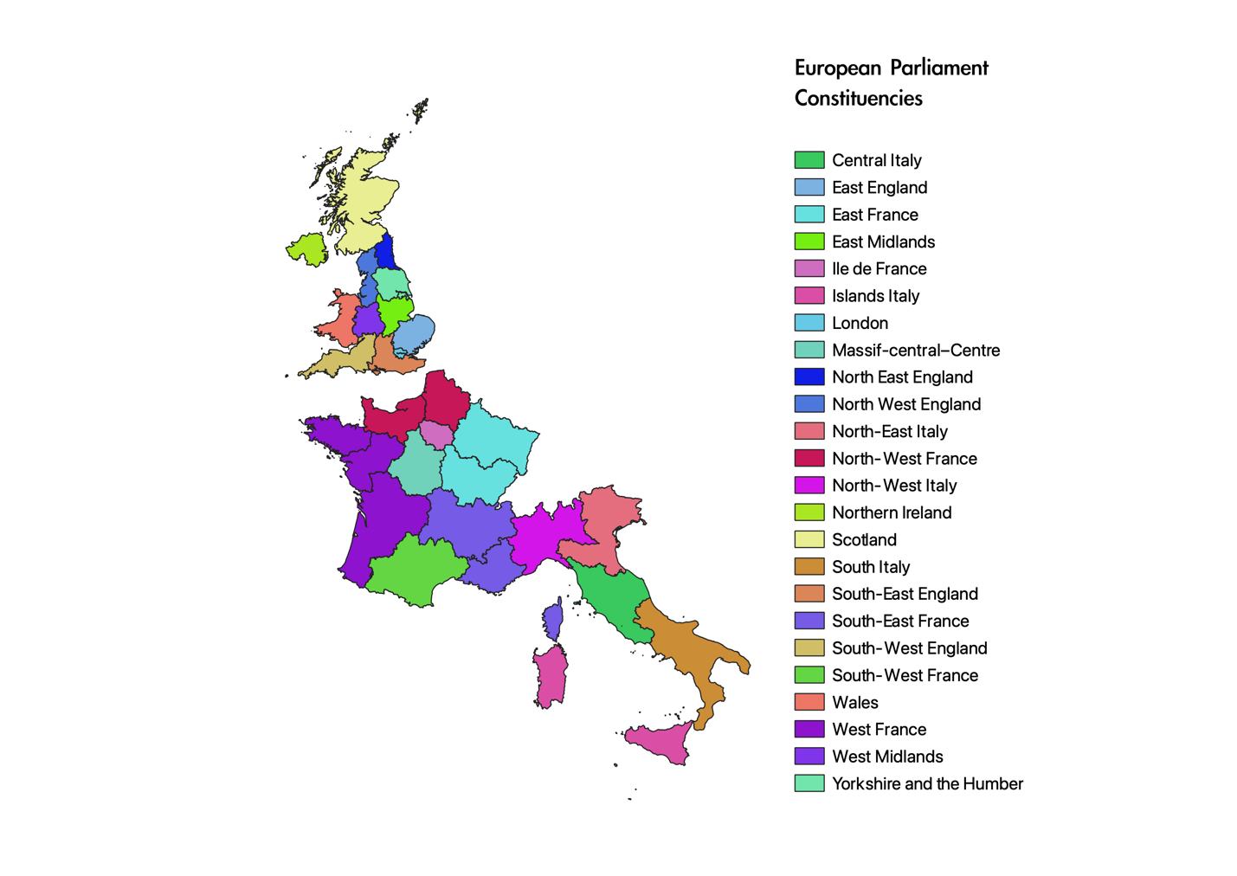

Map 1: 24 European Parliament Constituencies Under Study

Research on the effect of electoral subdivisions on MEP voting patterns has been lacking, and the field is likely to offer some invaluable insight on how MEPs represent their constituencies. Using MEP survey data, Bowler and Farrell observe that in general voters served by MEPs at the constituency level are better represented than those represented by national MEPs.[31] Assessing the effects of electoral rules on representative roles, Farrell and Scully argue that two main components are responsible for much of the influence: *ballot structure* and *magnitude*. Ballot structure distinguishes between 3 types of representation: “open”, “ordered” and “closed”. To paraphrase: “The open systems – in which the candidates’ electoral fates are affected by their personal vote-chasing activities – are used in nine cases […] At the other extreme, closed systems – in which candidates’ electoral fates are determined by their party list placement – are used in eight member states. Finally, there are ordered list systems, in which there is some limited scope for candidates to improve their list placement through personal votes. These are used in nine member states”.[32] The three countries under study have variation in their ballot structure: France and the U.K. have closed and party-based systems, while Italy has a mix of open and ordered list systems. They conclude that candidates elected on open lists are much more responsive to their constituents than others stemming from party-based list, with a notable exception for the U.K., despite being on a closed list, the countries’ own parliamentary system and political culture have made British MEPs much more responsive to their constituents than others. On the other hand, magnitude did not have a significant effect. However, Farrell and Scully use MEP survey questions as their dependent variable to assess how closely MEPs “care” about their constituents (how often the MEPs visits their constituents, whether they have offices in their constituencies and so forth). While they do not seek to assess the relationship between voter preferences and voting behavior, their segmentation of electoral rules gives us useful clues to pursue our analysis.

Other lines of analysis have focused on other factors, such as the role that political parties play in determining variation in representation at the EP. Marsh and Norris note that traditional models of representation which focus on the “matching” between policy demand and supply lead to the understanding of MEPs as representatives of their parties first and foremost.[33] However, the reality is much different because political parties do not have concrete, policy-driven platforms. Furthermore, there is such a concentrated degree of elite consensus around certain issues, such as furthering European concentration and monetary policy that there is little variation amongst party level policy supply. The authors conclude that there is effectively no linkage between the voters and MEPs, and this is reflected in the paltry turnouts at EP elections.

As such this paper will fill substantive, geographical and methodological gaps around the democratic deficit and the modeling of public opinion and its relationship with elected official voting behavior. In particular, it will shed additional light on patterns in constituency level preferences regarding environmental regulation, and how MEPs vote in return. There were two main reasons for choosing the environment as a case study: first, citizen attitudes towards fighting global warming and protecting the environment have been heavily surveyed by Eurobarometer, allowing the construction of a large sample of attitudes throughout time.

Furthermore, the EP has voted extensively on environmental matters over the past two decades, opening the possibility to correlate citizen preferences with MEP voting patterns. In fact, while the EP’s role has historically been quite limited, the recent years have offered it greater leeway in playing an active role in tackling climate change. For instance, the Environment, Public Health and Food Safety Committee “was the ‘largest customer’ of co-decision legislation within the Parliament from 1993 to 2006. The Committee’s “radical activism” and the passage of the EU’s Emission Trading Scheme (ETS), a major piece of legislation establishing the world’s largest carbon market, have cemented the EU’s reputation as a stalwart in the fight against global warming.[34]

**c. Hypotheses:**

This paper will test the following two hypotheses that were identified as being plausible in

the literature review.

*H0: There is a positive and significant relationship between voter preferences and MEP preferences.*

First, we should expect constituent level voter preferences and MEP preferences to be positively correlated and statistically significant. Although severe doubt has been cast on MEPs’ ability to represent their constituents overall, previous research has shown a tendency for higher representation at regional levels.

*H1: Italy and the U.K. have a higher degree of positive correlation between voter preferences and MEP preferences than France does.*

As identified by Bowler and Farrell, Italy and the U.K. should have a higher degree of positive correlation between voter and MEP preferences, because Italy has an open and ordered electoral system which allows voters to choose and order candidates that are more likely to represent their interests, while the U.K. has a culture and tradition of political representation that has fostered deeper connections between MEPs and their constituents. On the other hand, France has a party-based and closed representation system, where voters are more likely to vote for MEPs representing parties they are ideologically aligned with.[35]

**III. Data and Methodology**

This paper’s analysis is divided into three parts. As discussed, the first step is to use MRP to estimate preferences at the constituency level, modeling survey responses as a function of demographic and geographic characteristics. After obtaining the estimates, an index is constructed with MEP votes on key issues surrounding the environment. The analysis spans a 15-year range (2004-2019), covering the 6th, 7th and 8th legislative terms at the EP. This is mostly out of concern for convenience as most of the publicly available data on MEP voting records are restricted to that range.

1. **Modeling Survey Responses**

We begin by fitting a multilevel logistic regression where survey responses are a binary

variable. For that purpose, 12 Eurobarometer polls conducted between 2004 and 2019 were obtained. These polls were classified as having a subset questions specifically targeting how respondents felt about various issues concerning climate change, environmental regulation and the role the EU can play in mitigating them. In all, three main question categories were selected: questions pertaining to climate change, environmental regulation and the trade-off between economic growth and sustainable development. While they are not conceptually equivalent, we are making the assumption that all of them inform broader attitudes towards environmental regulation to some meaningful degree. Additional research could perform separate analyses for each category and find associated EP legislation as well. All of the polls dated and their associated codebooks were obtained from gesis.org.[36]

Typical survey responses include questions that can easily be coded as 1 (support) or 0 (oppose). Other questions are given a higher range of responses, in which case they are recoded as 1(0) if the respondent has any level of support (opposition) to the question.

A few examples include:

* Eurobarometer 75.2 - Question B8: *Which of the following ways of evaluating progress in (OUR COUNTRY) do you think is the best? National progress should be evaluated based on:*
  1. Mostly on economic criteria, such as GDP (Growth Domestic Product)
  2. Equally on social and environmental and economic criteria
  3. Mostly on social and environmental criteria
* Eurobarometer 75.2 - Question B10: *To what extent do you agree with the following statements?* 
  1. The protection of the environment can boost economic growth in the EU
  2. The efficient use of natural resources can boost economic growth in the EU
* Eurobarometer 88.1 – Question D20: *The EU is supporting environmental, nature conservation and climate action projects in all Member States through financial instruments such as the LIFE Programme. Please tell me to what extent you agree or disagree with the following statement: “The EU should invest more money in projects and programmes supporting the environment, nature conservation and climate action throughout the EU.”*

1. Totally agree
2. Tend to agree
3. Tend to disagree
4. Totally disagree

The Eurobarometer also asks respondents to provide their age, gender as well as their marital

status. Our options to conduct poststratification are limited to these three variables as they are the only ones consistently surveyed throughout the years. Future research should look into the possibility of creating synthetic poststratification tables to allow for a wider range of demographic variables to be included, such as education.[37]*

The logistic model predicting a respondent’s probability of supporting / being in agreement with a certain question is the following:

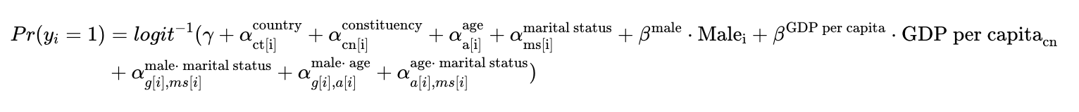

With:

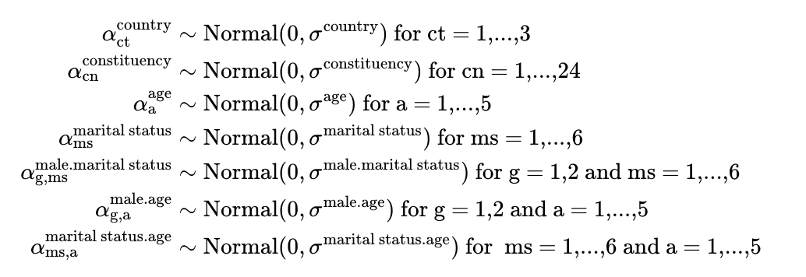

The model’s independent variables include the 3 aforementioned demographic predictors, the constituencies’ *GDP-per-capita* as well as random effects for each constituency and each country. This is a textbook hierarchical model, with individuals nested in constituencies, which are in turn nested within countries. *GDP-per-capita* was not directly available in the Eurostat data sources for constituencies, so it was constructed as the population weighted average of the various NUTS regions that constitute the constituencies (refer to Map 1). Including predictors for the geographical units under study is recommended by Lax & Phillips and aims at improving the overall model fit by providing extraneous information about the geographic units.[38] Several other potential variables were available via Eurostat, such as a region’s unemployment rate and its share of population with tertiary education. Several models were fit using combinations of these variables, and it was concluded that *GDP-per-capita* would work best, as the other variables were uninformative. Research using MRP in the U.S. often uses variables such as a state’s share of the vote going to a Republican candidate as variables trying to capture underlying political attitudes in the state, but such variables are not readily available for Europe. Using *GDP-per-capita* is then somewhat due to lack of alternative but is still a useful predictor to include in the models.[39]*

The 𝛼 (*alphas*) in the model correspond to varying intercepts. In essence, this means that we allow for the different levels of our data – for instance the 6 different categories for marital status – to inform one another, partially pooling the coefficient towards the group mean (there is no varying intercept for *gender* since it only has two levels). This is particularly useful when certain values of data do not occur frequently enough, or at all, to properly inform the model’s estimation. If our sample does not have any positive responses in support of a question for a certain demographic group, say 20-25 years old, the model would estimate β20-25 as -∞, an erroneous statistical artifact due to insufficient sampling. Interactions between the demographic variables are included, something recommended by Ghitza and Gelman.[40] We can think of the interactions as additional information for “free”, in the sense that they do not require additional data, while still providing useful insights.

We fit the models in R using the rstanarm package which allows for a rapid estimation without having the write code directly in the Stan programing language. Stan uses a variation of Markov Chain Monte Carlo called Hamiltonian Monte Carlo in order to perform parameter estimation. Because we are estimating models in Bayesian framework, the question of what priors to choose arises. Specifically, we have the option of specifying three classes of priors: one for the model coefficients, another one for the intercepts (from the mixed effects), and finally for the variable covariances. In this case, we are going with Stan’s default option of providing non-informative priors (which are drawn from a normal distribution centered at 0 and with a scale of 2.5), although future research should look into careful selecting adequate priors to better informs the model parameters.[41]

In total, XXX models were fit using rstanarm. For instance, Figure 1 on page XXX displays the regression coefficients from modeling responses for Eurobarometer 88.1 Question 20D (should the EU invest in more projects aimed at tackling climate change). Most of the coefficients are noisy but still instructive: most of the variation in our model comes from the regional effects. The first 3 parameters are the model’s intercept – the average level of support for the question when other GDP-per-capita is equal to 0, when the respondent is *not* a male. The *b[Intercept]* are the average outcomes for each of the categories in our demographic and geographic variables. For instance, the value for the *South-Italy* constituency is negative and more than 2 standard errors away from 0, signifying that respondents from that constituency are very likely to not support the EU’s endeavors to tackle climate change. Finally, the 7 parameters at the bottom of Figure 1 are the variables’ respective *Sigmas* – the variation across the different variable levels (high sigmas, such as the one for countries, show there are high levels of variation between Italy and the U.K. for instance).

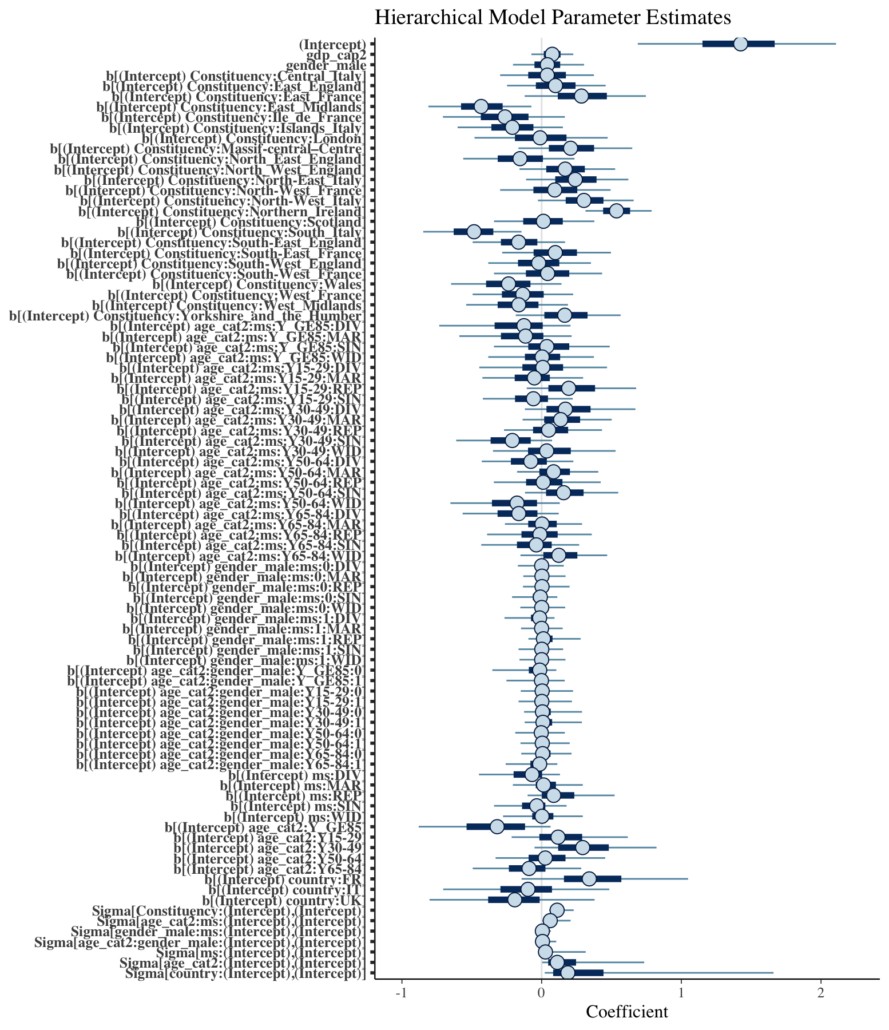

Figure 1: Modeling Respondent’s Attitudes Towards the EB88.1 Qd20: EU Investing More to Protect the Environment.

An important component of a Bayesian framework is modeling critiquing. The rstanarm package offers a set of visualize tools to ascertain whether our model captures variation in the data accurately. For instance, we can perform posterior predictive checking (PPC) to compare the observed data with simulated data from the posterior predictive distribution by overlaying their densities, as seen on Figure 2. To reiterate, Bayesian modeling offers the opportunity to work with posterior distribution of our estimates, as opposed to a single point estimate. By working with parameter distributions, we can simulate data that is consistent with the data that we’ve observed and compare the outcomes. In this case, the model appears to capture the observed data quite well, as evidenced by the multitude of simulated datasets that track the observed data’s variation.

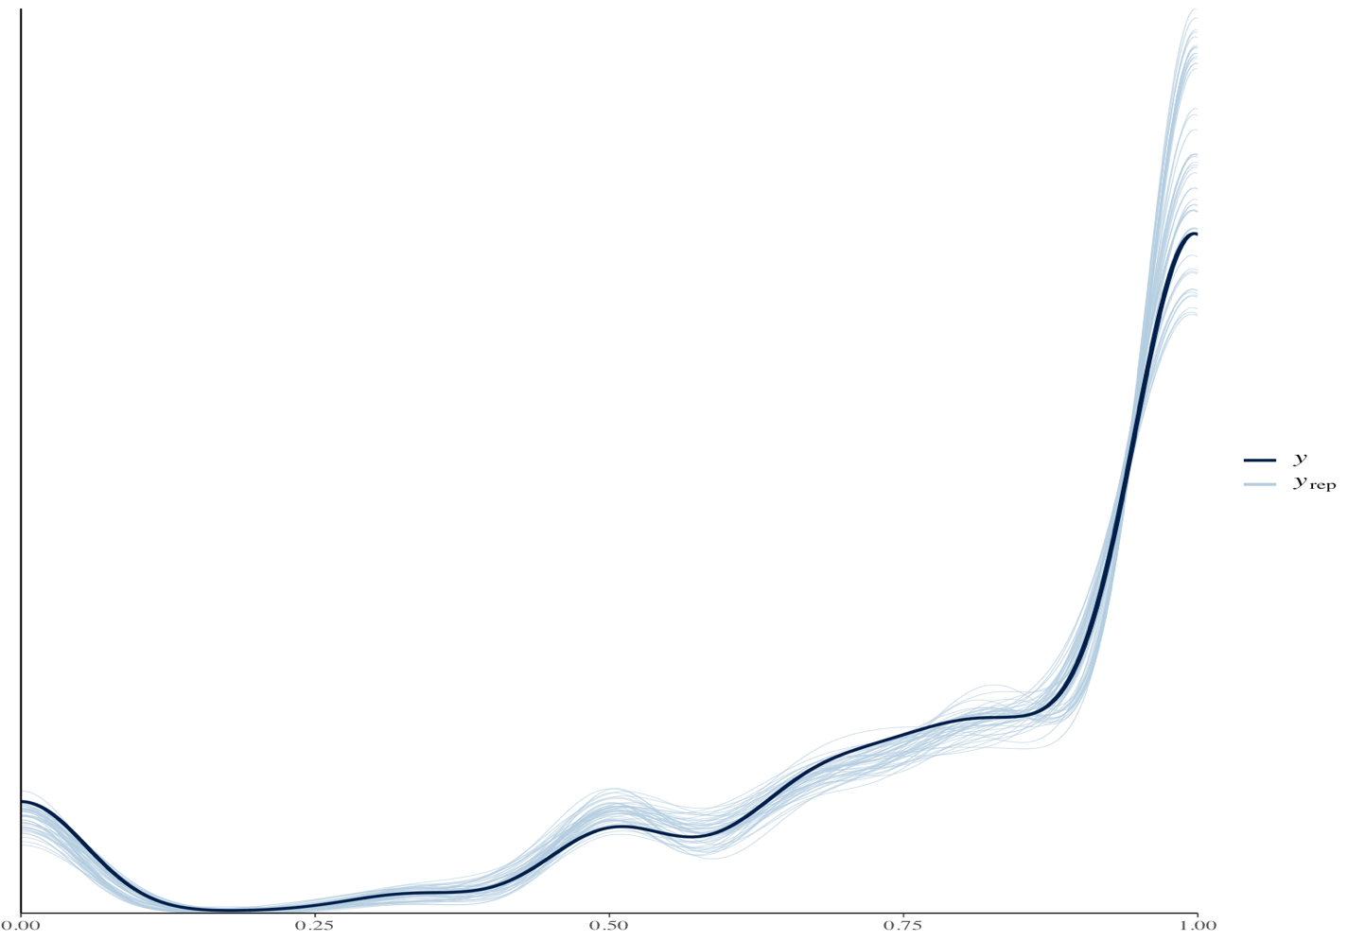

Figure 2: Posterior Predictive Distribution

1. **Poststratification**

Now that we have our model parameters, we can perform the post-stratification step, where the actual demographic composition of the populations under study are used to weight the model parameters. Using Eurostat Census data from 2011 we can easily collect demographic data for the three categories we are interested in: age, gender and marital status.[42] A certain combination of demographic characteristics is called a *cell*. Table 1 displays a typical poststratification file. Using the 2011 census, we can get the cell composition of the Ile-de-France constituency: for example: there are 957 Widowed females that are aged 15-29.

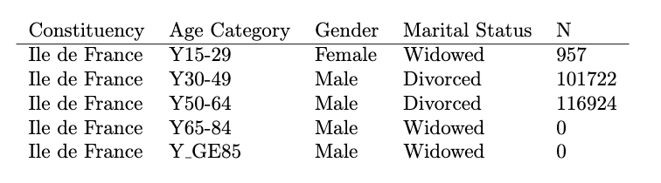

Table 1: Poststratification File

For each of the models estimated for the 72 questions in our EB surveys, and for each of the 24 constituencies in our sample, we simulate 1000 (the default amount of draws in the rstanarm package) draws from the models’ posterior predictive distributions, this time using the population cells as weights, in order to build constituency level preference estimations.

For instance, the Ile de France constituency has 70 different cells. As such, the resulting posterior distribution file is a 1000 x 70 sized matrix, 1000 estimates for every cell type. For the first cell, the resulting estimated level of support is plotted as a histogram in Figure 2. For this constituency, there is a high level of support, which is unsurprising given that it represents the greater Paris region, and support for environmental regulation and fighting climate change tends to be high in urban centers.

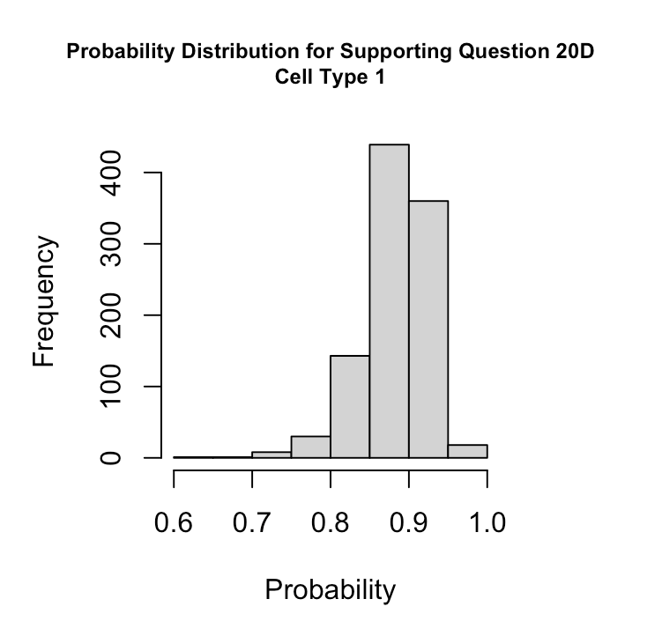

Figure 3

Finally, the estimates are weighted with the actual population composition (the *N* in Table 1). We use matrix algebra to multiply the 1000 x 70 matrix by an 70 x 1 matrix (the relative frequency in the population of each cell). This results in the 1000 x 1 vector with the population weighted estimates for the entire constituency.

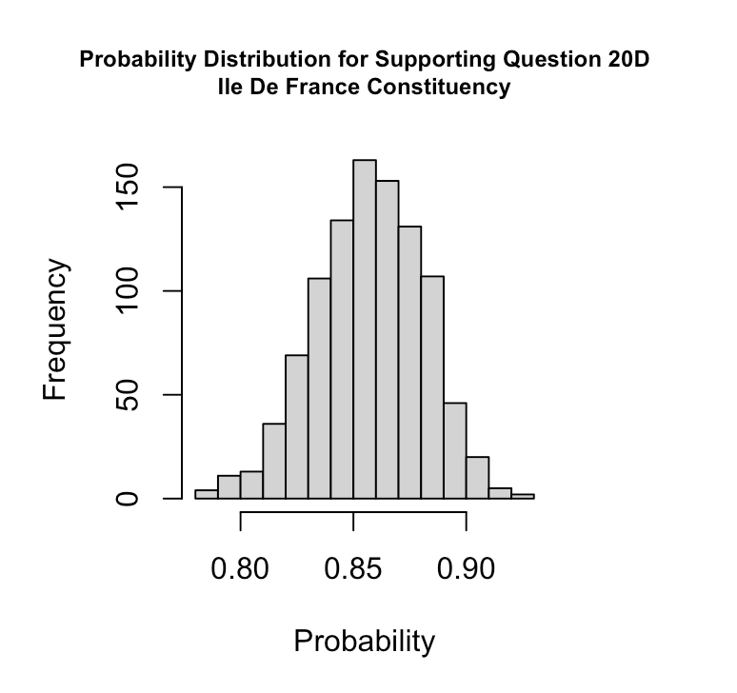

Figure 4

Repeating the process for all 24 constituencies in our sample, we can assess the distribution in the level of support for Question D20, as shown in Figure 5. We can then repeat the same process for all of the questions in the 12 EB surveys, calculating an average for the entire sample, as shown in Figure 6. It is noteworthy that an important advantage with working with posterior distributions using the rstanarm package is the availability of a model’s standard error. The proper modeling of uncertainty is an axiom of Bayesian frameworks, and frequentist implementations of preference estimation (via disaggregation or using the LME4 package in R) do not come with ready-made standard errors, which involves additional, time consuming steps.

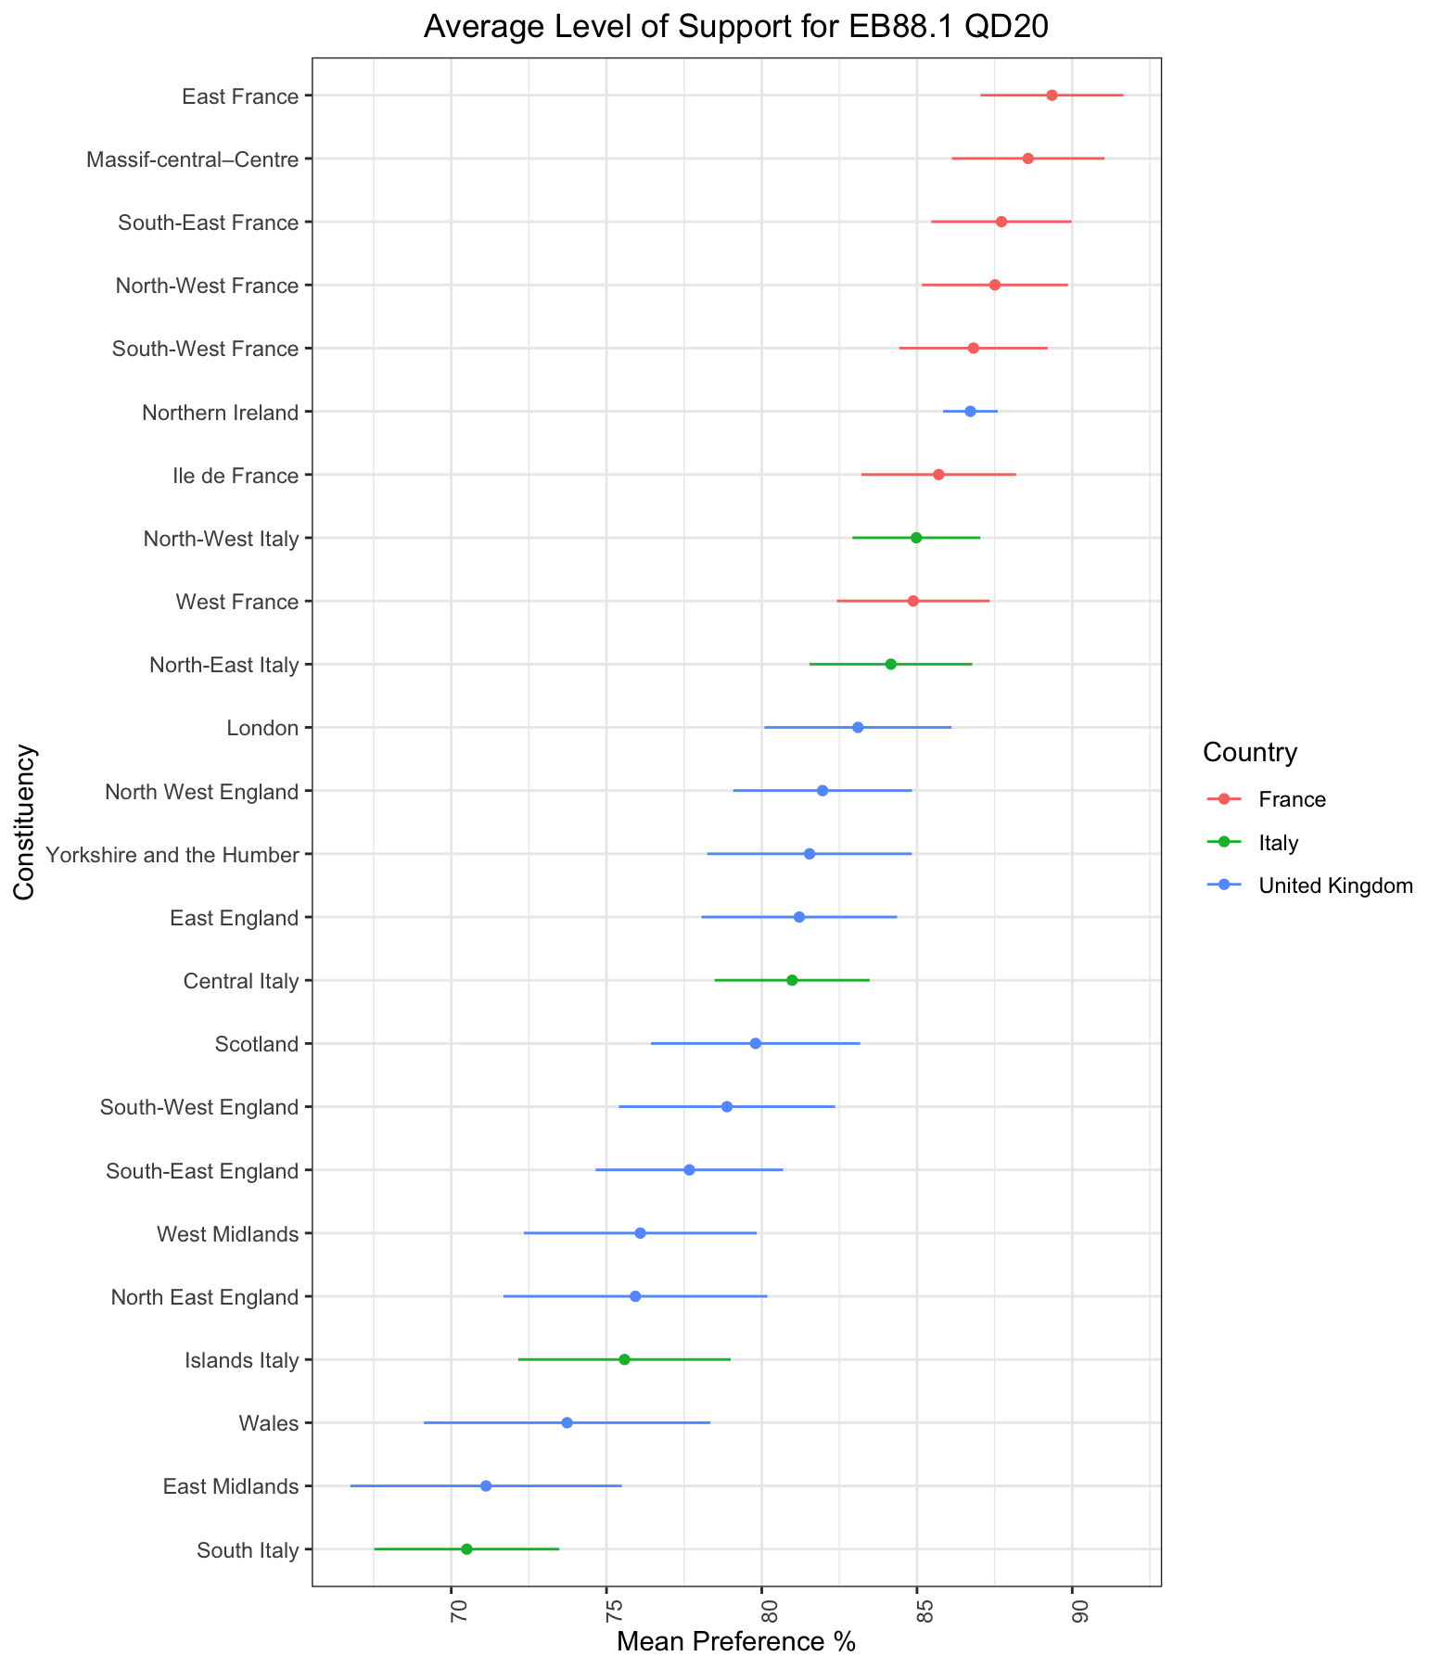

Figure 5

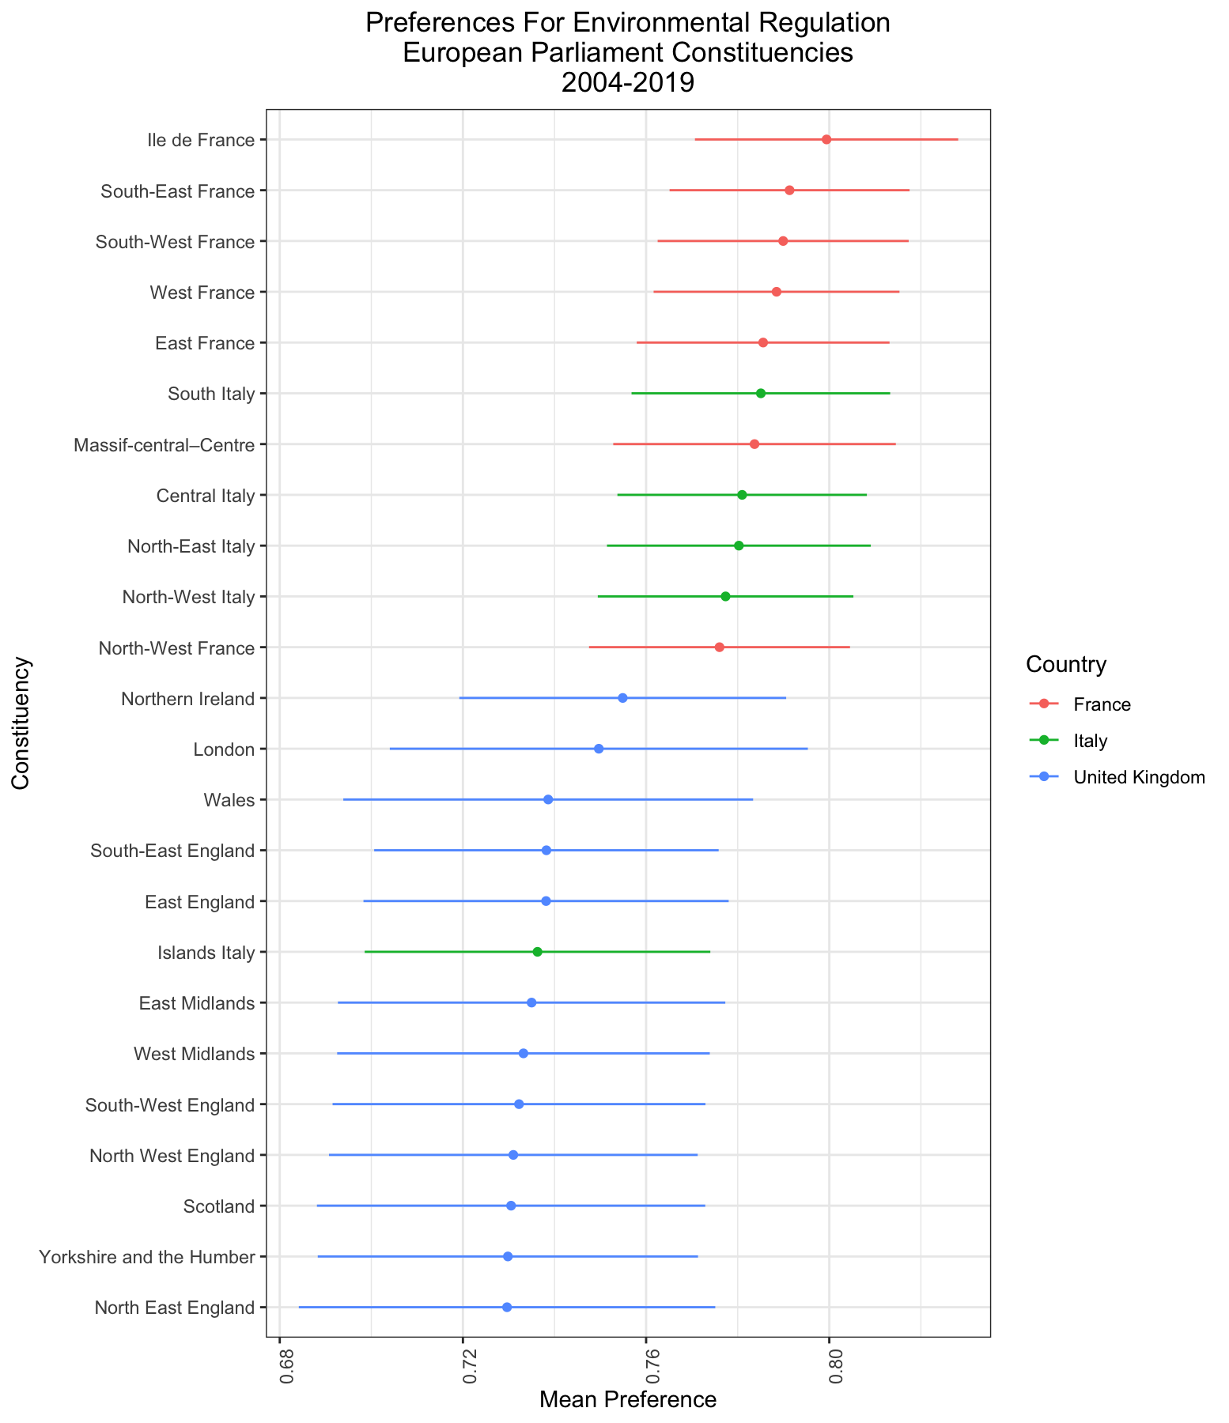

Figure 6

Figure 6 shows that while there is little evidence of intra-country variation, there is ample evidence of variation between the different constituencies when looking at the entire sample. Something to reiterate is that these aggregate measures of preferences are simply the result of averaging the probabilities for respondents in each constituency to respond positively to the questions they were ask. While the questions do not seek to assess support for a particular policy, the resulting models can be invaluable in better understanding how preferences are distributed within the EU. For instance, the British appear to have the lowest level of support for the 3 countries under study, while the French come out on top. A tempting explanation for the variation could be found in levels of support for the EU, but recent surveys have found that the French were much more Euroskeptical than the British.[43]

We can also disaggregate the results by parliamentary term, as shown in Figure 7. First, we can see that while the average preferences stayed stagnant during the first 2 legislative terms in our sample, there is a noted increase in the last term (which coincided, *inter alia* with the heavily mediatized COP21 Paris Accords conference aimed at fighting global warming). Second, British respondents were markedly displaying the lowest levels of support throughout the entire sample, with the French on top and the Italians in the middle.

With constituency-level estimates of support for environmental in hand, we can now turn to modeling MEP roll call votes in order to quantify the correlation between the two variables.

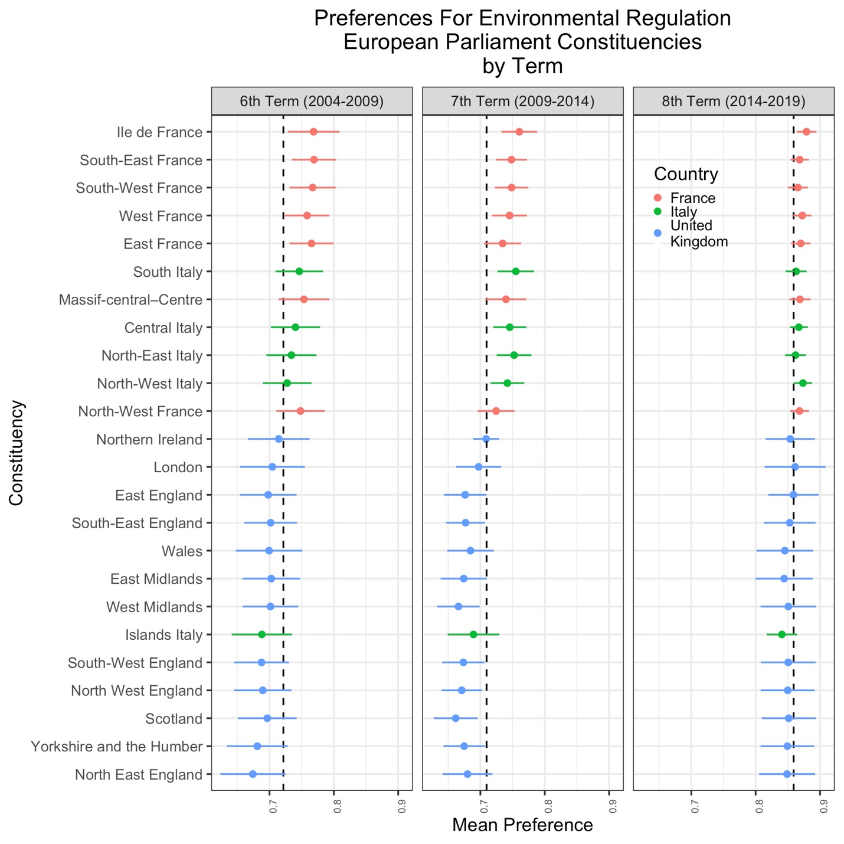

Figure 7

1. **MEP Roll Call Votes**

The first step was to build a dataset with all of the MEPs elected in the 3 legislatures under study. To that effect, a database with the names of 700 MEPs for the 24 constituencies in the sample was put together. Using the MEPs’ EP party affiliation, each one was attributed an ideological category based on a 7-point scale (Far Left, Left, Center, Right, Far Right, Greens and Others).

The second step to understand how MEPs vote was to build a dataset of laws aimed at fighting climate change and protecting the environment. Using the EC’s own “Environmental checklist” provided an initial list of EC proposals that were voted on by the EP.[44] Eur-Lex, a repository for EU legislation, also provides a useful link to all of the laws passed by the EP, arranged by topic.[45] Finally, additional laws were identified by perusing research from specialized think tanks.[46][47] In all, 33 laws were compiled: 8 from the 8th term, 11 from the 7th and 14 from the 6th terms.

Finally, MEP voting records were obtained from parltrack.org, a website that maintains extensive and publicly available documentation on MEP activities such as plenary votes, speeches and committee activities. The website attributes and ID to each MEP and each law. To that effect, a parser was designed in Python to extract the MEP IDs by looping over all of their names in the database and performing a search on parltrack.org, then copying the ID (usually found in the URL) and pasting it in the dataset. The MEPs whose IDs could not be obtained that way were filled in by the author performing the searches “manually”. It was now possible to see if MEPs voted in favor of a law (coded as +1), against it (-1) or whether they abstained (0). Unfortunately, several laws were not included in the parltrack.org master file, or were voted on “by hand”, which means only the outcome was recorded. Figure 8 displays the distribution of the MEP voting preferences. The distribution is peaked to the right: MEPs have a high tendency to vote in favor of legislation around climate change. As several scholars have noted, there is a clear institutional bias within the EU and the EP which favors the adoption (as opposed to the outright rejection) of policies, as many of them originate from EP Committees who work in conjunction with the Council to propose certain laws.[48]

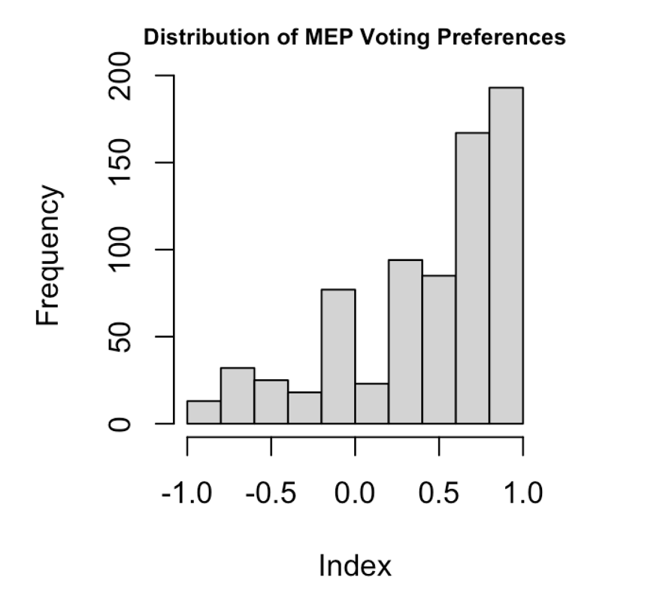

Figure 8

Figure 9 below displays the variation in voting patterns by tallying and aggregating data at the constituency level. The standard deviations in the plot tend to be quite due to the relatively low sample size of available legislation, but we can see there is substantial variation within countries and within the entire sample.

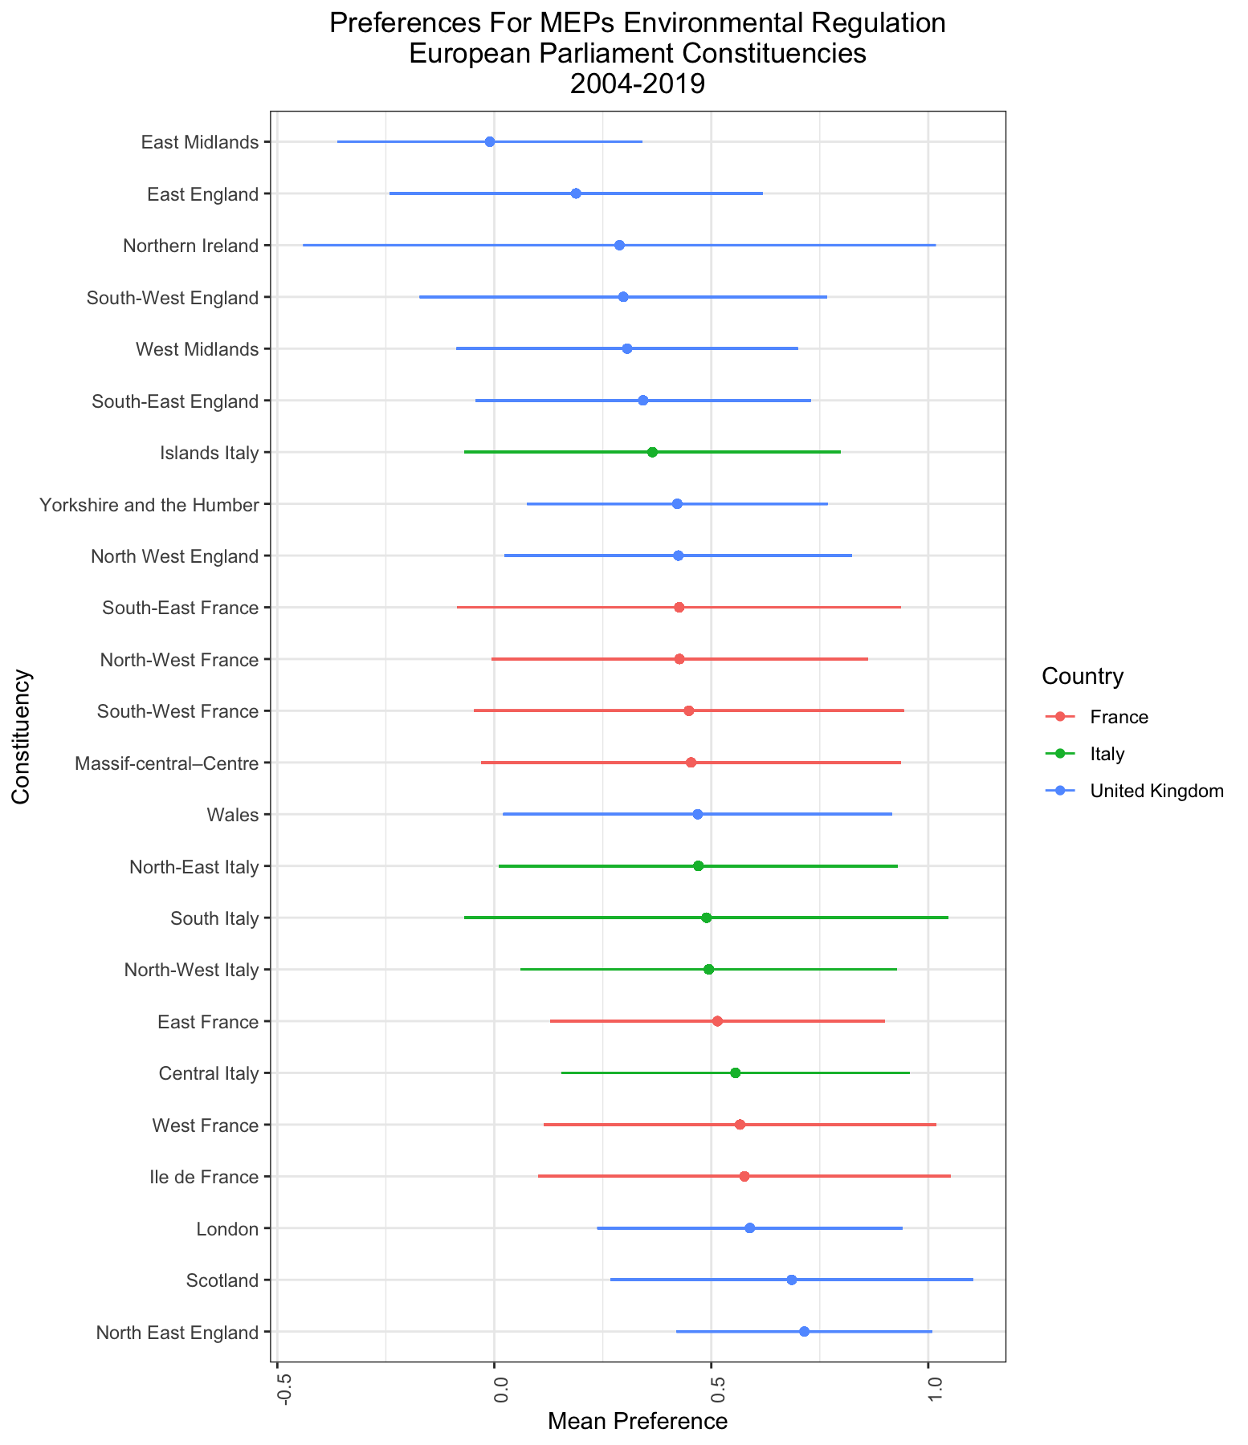

Figure 9

Figure 10 plots the variation of MEP preferences over time. Interestingly, there is a reversal in the overall average preference in the 8th term, with the average preference dropping from around 0.5 to 0.25. This is possibly a statistical artifact stemming from a lower amount of available voting data for the 8th term. Interestingly, the constituencies with the highest level of support for environmental regulations for citizens, which were all French, are not in the top 3 constituencies. On the other hand, the bottom preferences are somewhat more similar, as they are composed of British constituencies, albeit in a different order.

Finally, Figure 11 plots the average support for policies as a function of ideology. The results might seem odd a first glance – for instance, the preferences for the Greens, who we assume would have a higher level of preference than any other political group by nature of their policy platforms, is lower than that of Right, Left and Center parties on average. The issue of unbalanced groups and small sample sizes in the dataset are likely culprits: there are quite a few constituencies without Green MEPs in our sample.

MEPs in groups on the extremes of the political spectrum have lower levels of support. In particular, MEPs from the Far-Right have tended to vote *against* legislation, as their mean level of support is the only one to be negative. The last years have seen academics and journalist study rising climate change denialism across the Western world, and have found that far-right groups are behind much of the organized political efforts to push forward such narratives[49], and this is reflected in the roll call votes.

MEPs classified as being in “Other” (officially *“Non-Inscrits”* in French, literally “nonattached”) groups also have low levels of support. MEPs in that category tend to come from regionalist parties, or are from EP groups undergoing restructuring. Because they are not aligned under a common ideological framework, their neutral levels of support are unsurprising.

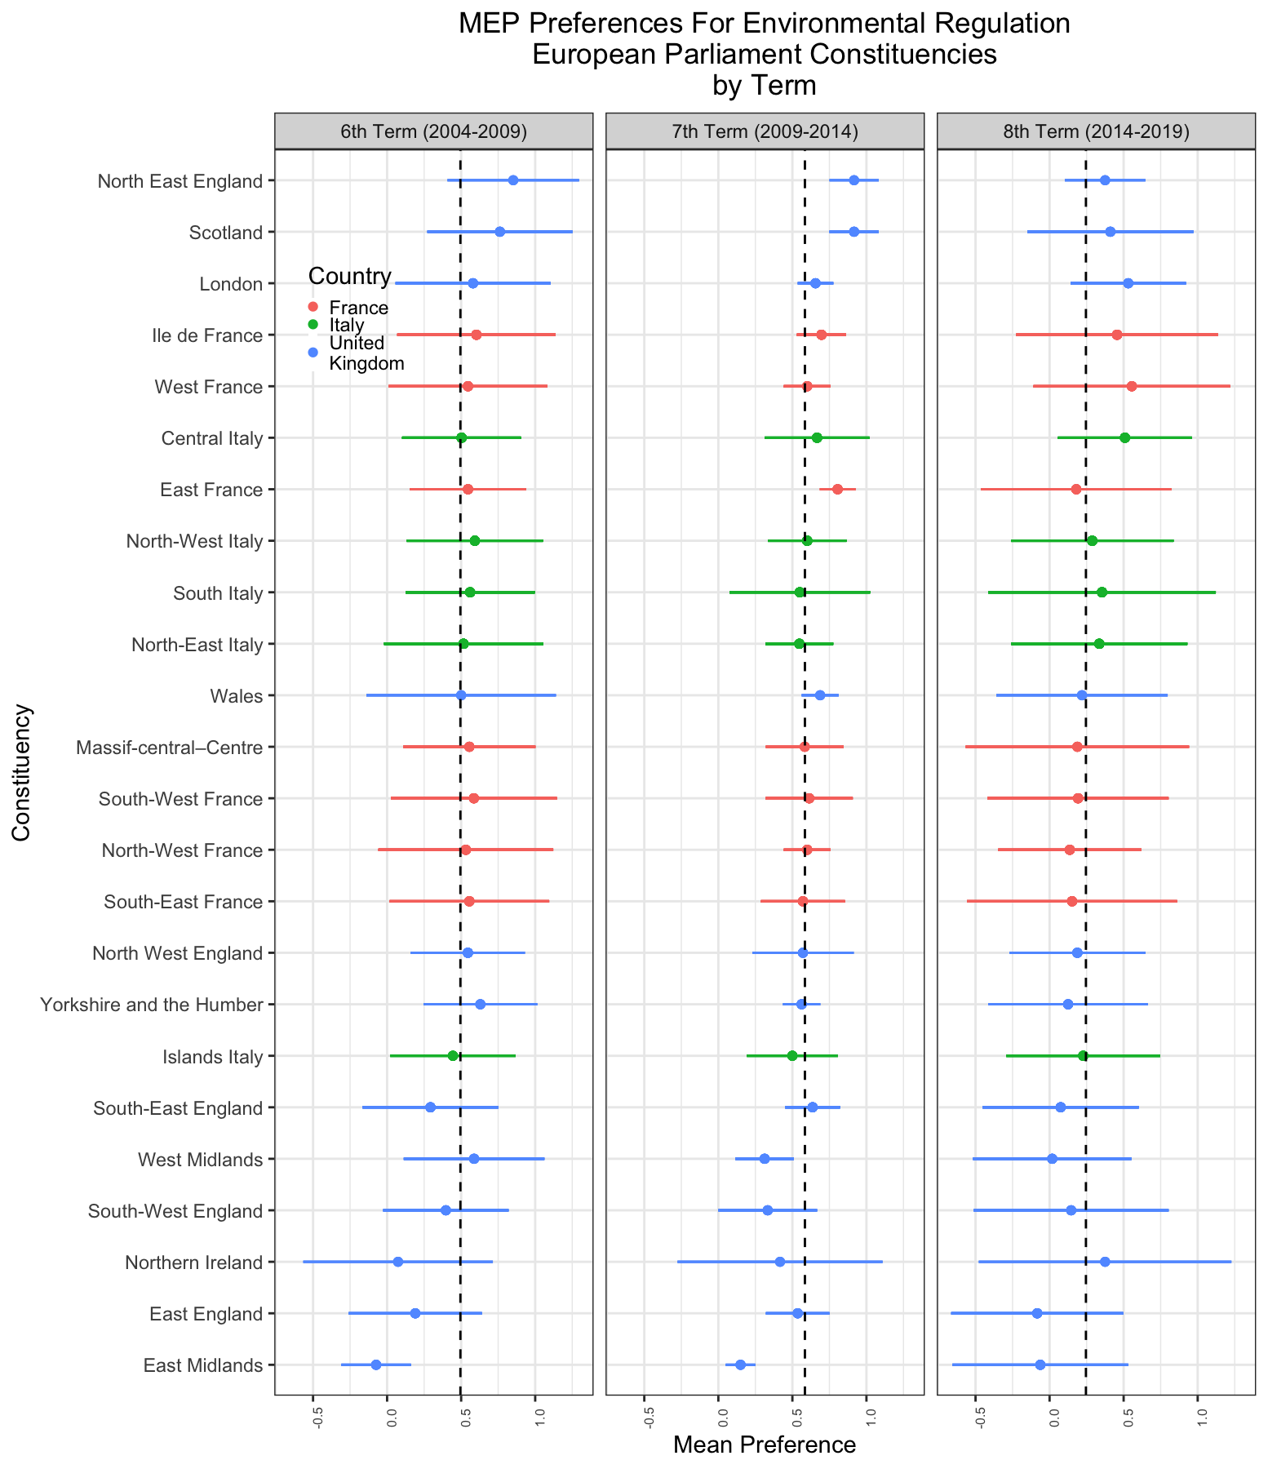

Figure 10

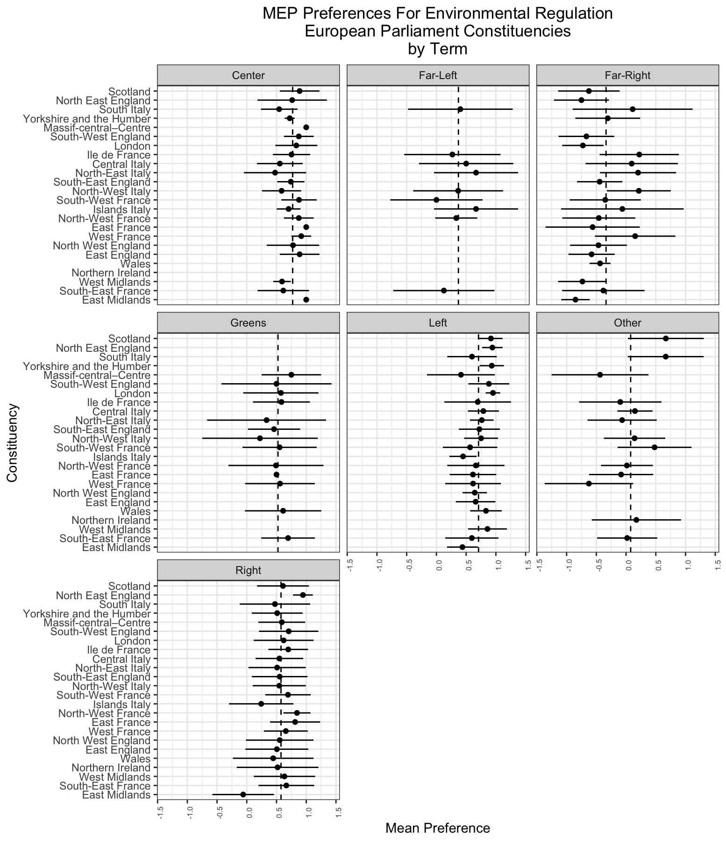

Figure 11

**IV. Results**

In order to quantify the democratic deficit, an Ordinary Least Squares (OLS) regression is fitted, with the MEP preferences as the dependent variable. Table 1 displays the regression model outputs. At first, the values are regressed again the constructed Citizen Preference Index (CPI). We find a positive and statistically significant effect; when comparing two individuals that are identical in every regard, a 1-unit increase for an individual is associated with a 2.302-unit increase for her MEP. At this point, it is tempting to pre-emptively conclude that when it comes to environmental preferences, the model’s findings are encouraging, and point to a positive correlation between citizens and their elected MEPs, a feature that Lax & Phillips term *congruence.*[50]

It is generally useful to explore alternative analyses and as such a second model is fit, this time using country and term fixed effects, to assess whether specific geographic and/or temporal factors could play the role of plausible alternatives. We are also interested in testing our second hypothesis, that Italy and the U.K. should have higher levels of congruence than France. After adjusting for these new variables, we find that the CPI, while still positively correlated to MEP voting patterns, is much more noisy and no longer significant. The country fixed effects show that both countries have positive correlations with how MEPs vote (in this case France is the baseline country), but the estimates are too noisy to conclude anything significant. Interestingly, the temporal fixed effect for the 7th and 8th legislatures (the 6th being the baseline) are both significant. For the 8th term, the coefficient is actually *negative*, something shown by Figure 10, where MEP support for legislation was much lower across the board.

A third model was fit, using additional adjustments in the form of the MEP’s ideology. With the baseline category as belonging to a Centrist party, the fixed effect coefficients show the deviations from the baseline.[51]* As alluded to previously, parties on the extremes have much lower levels of correlation than parties closer to the ideological center. Interestingly, the coefficient is now statistically significant at the 5% level, being more than two standard errors away from 0. The third model’s R-squared, a measure for goodness of fit, is also much higher, indicating that the inclusion of ideological effects was beneficial and made our model more precise.

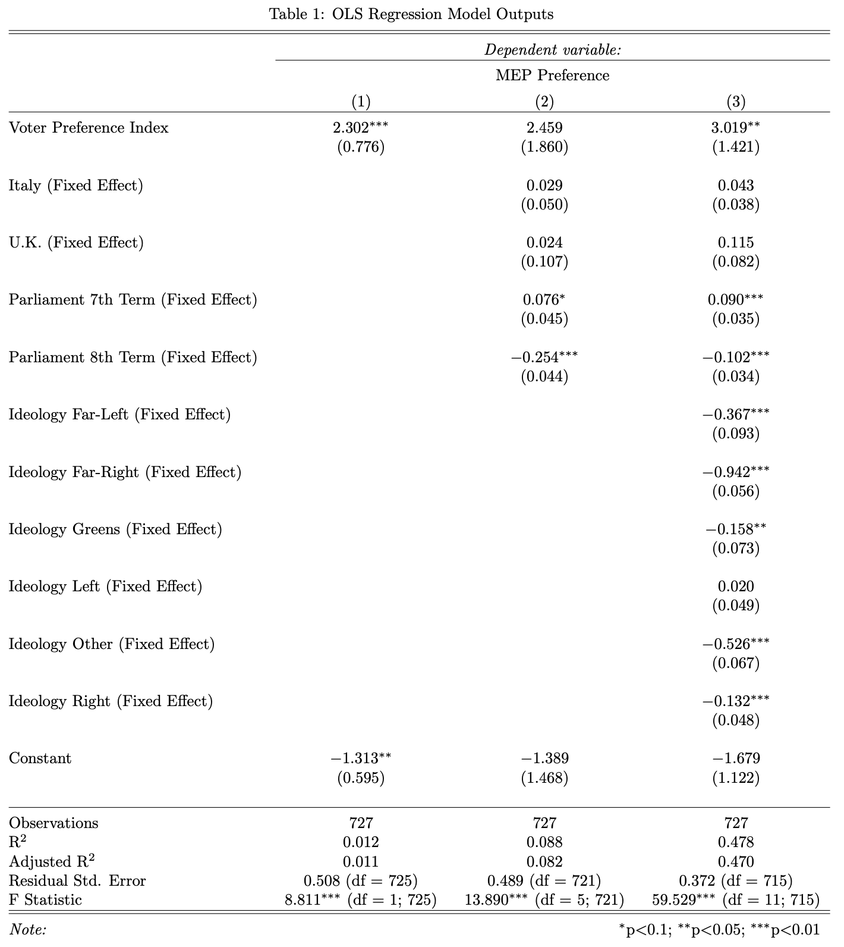

A fourth model was also fit, this time regressing MEP preferences on the citizen preferences (which were centered around their mean) and using constituency fixed effects. Map 2 provides a visualization of the model coefficients, with congruence calculated by summing the regression’s intercept, which is equal to the base category (Central Italy) when citizen preferences are at their mean value, and the fixed effect intercepts for each region.

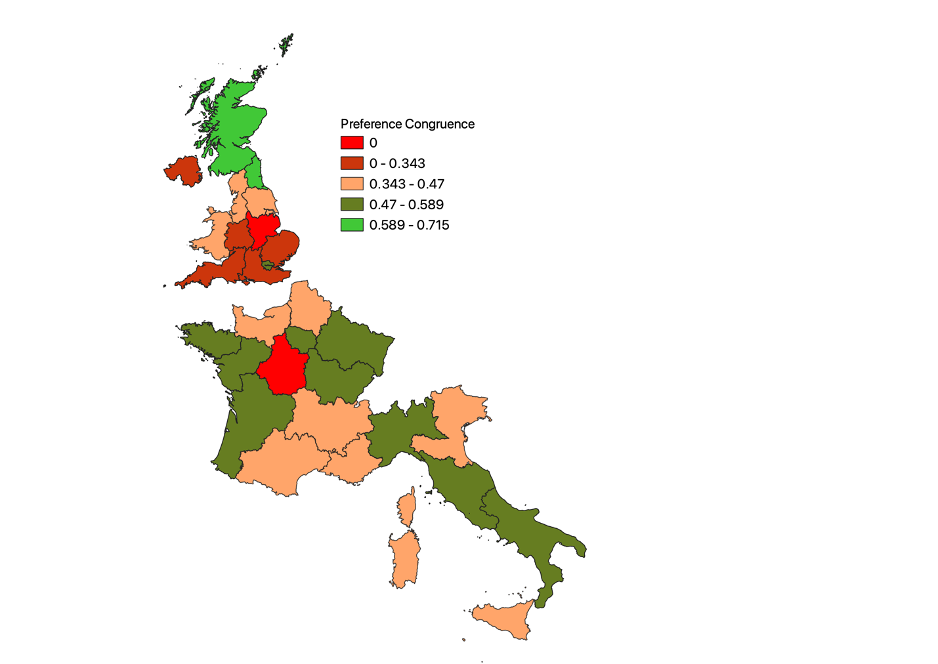

Map 2: Distribution of Congruence Across the 24 Constituencies

To conclude, this paper’s analysis shows that the relationship between citizen and MEP preferences is more complex than meets the eye. Although a positive and statistically significant relationship between the two variables is not necessarily indicative that voter preferences *cause* MEPs to vote a certain way, they nonetheless demonstrate a level of congruence that would likely reassure the EU’s supporters. As the next section discusses, there are a couple of methodological and substantive issues that should warrant caution.

**V. Discussion / Caveats**

Although this paper’s findings are surprising, they must be taken with a grain a salt. First, while MRP is a tremendously powerful tool to estimate preferences is not a panacea. The most glaring issue comes from the fact that most surveys do not prompt a respondent about a specific policy. Instead, the polls questions prompted respondents to tell how they felt about broad questions pertaining to the environment. The relative appropriateness of a survey question as an indicator of an underlying preference for policy is a particular manifestation of what Haynes et. al term *content validity* - the degree to which the components of a measurement process are relevant to and representative of the targeted construct under study.[52] In fact, the lack of content and more broadly, construct validity (whether a measured phenomenon is at all measuring what it is supposed to be measuring) for analyses using survey data to estimate climate change preferences has been highlighted in academic literature.[53]

Another complication arising in this paper’s analysis pertained to the inconsistency in the questions asked throughout the available sample. As such, we are making a conceptual leap by throwing in responses to questions about climate change together with questions about environmental regulations, which are not at all equivalent. The analysis would be greatly enhanced by the use of Item Response Theory (IRT) models, whose purpose are to better extract underlying preferences by combining responses to different questions about a same topic.[54] Recent work has also looked into applying multilevel models to IRT in order to tackle the aforementioned issues, and future research should look into applying them to this analysis.[55]

The MRP models used in this paper can also be improved. An important task is to find regional-level (and potentially country-level) predictors that are both theoretically and empirically sound. As mentioned earlier, existing research applying MRP to survey data in the US makes use of Republican or Democrat vote share as a proxy for underlying political belief. Because European countries tend to have higher numbers of political parties, the task is a bit more complicated, albeit still possible. If measuring environmental preferences, then the share of the national Green party at the last domestic elections in the region could be a strong initial choice. When measuring preferences for international trade, then perhaps the region’s export as a percentage of GDP could be applied instead.

It would also be possible to improve individual-level predictors. The EB asks for a respondent’s political alignment, which is likely to be a major factor affecting his preferences. Unfortunately, the European census does not collect data on political alignment, which would force researchers to look for other sources of data. That being said, whatever the issue to be analyzed, discovering what constitutes good individual and regional predictors is likely to become and exciting and productive field.

Finally, MEP preferences can be ameliorated by delving into the legislations’ amendment structure. The laws that were used in this paper were the product of countless debates and were subject to numerous amendments before being introduced as their final versions. Looking into amendments is challenging because they are often redundant, and sometimes entirely disregarded when laws come into effect.[56] However, specialized think tanks and research centers often provide useful lists of amendments they believe to be important for the topic at hand.[57] MEP preferences could also be better modelled, for instance by using the NOMINATE algorithm to capture patterns in roll call votes, as opposed to using simple for/against/abstain averages.

The second set of criticism is substantive in nature. As laid out before, waning levels of trust in the EU and poor understanding of its objectives and structure have resulted in low levels of electoral participation in EP elections and general disinterest in the institution to begin with, and while preference congruence is surely a positive sign, it can only be do so much if European citizens do not believe in the MEPs they elect. Another factor is related to *issue salience*: perhaps the environment does not matter as much as other issues, say the economy, and while certain citizens might feel deeply about their desire for more environmental regulation, it is actually not one of their main concerns when assessing who to vote for.

**VI. Conclusion**

The analysis conducted in this paper points to an encouraging fact: MEPs tend to vote in accordance with their constituent’s opinion. By applying MRP to sub-national level units in the E.U. and then correlating them with MEP voting behavior, this paper has contributed to the existing literature in three different ways. First, it has demonstrated the feasibility of applying MRP to Eurobarometer surveys going back nearly two decades. Although certain individual-level predictors, such as *marital status* are imperfect on their own, they do hold some value when interacted with other variables. Future research should look into deploying alternative methods, such as synthetic MRP, if no better predictors can be found. Second, by delving into MEP preference estimation at the sub-national level, this paper fills an empirical gap ignored thus far by political scientists. Although some of the methods presented here could be further developed, and the number of countries in the sample increased, it provides a useful starting bloc for statistical analyses centered around democratic linkages between citizens and elected officials.

That being said, we believe this line of research should be extended and applied to different topics, as well as countries that were left out in the analysis, such as Belgium, Ireland and Poland. While the issue of the environment is highly debated and relevant to contemporary political debates, the EP has also been active on a number of other fronts for which investigating preference congruence would be highly productive, such as international trade, LGBTQ+ discrimination and even European integration itself.

**ANNEX: DATA SOURCES AND MODEL CONSTRUCTION**

All of the code used for this thesis can be accessed on the author’s GitHub: <https://github.com/gabgilling/Thesis>

|  |  |  |  |
| --- | --- | --- | --- |
| GESIS ID | EB NUM | DATE | PARLIAMENT |
| ZA4230 | Eurobarometer 62.1 | Oct-Dec 2004 | 6 |
| ZA4742 | Eurobarometer 68.2 | November-December 2007 | 6 |
| ZA4744 | Eurobarometer 69.2 | Mar-May 2008 | 6 |
| ZA4971 | Eurobarometer 71.1 | Jan-Feb 2009 | 6 |
| ZA4975 | Eurobarometer 72.1 | Aug-Sep 2009 | 7 |
| ZA5480 | Eurobarometer 75.2 | April-May 2011 | 7 |
| ZA5877 | Eurobarometer 80.2 | Nov-Dec 2013 | 7 |
| ZA5914 | Eurobarometer 81.3 | April-May 2014 | 7 |
| ZA6595 | Eurobarometer 83.4 | May-June 2015 | 8 |
| ZA6861 | Eurobarometer 87.1 | March 2017 | 8 |
| ZA6925 | Eurobarometer 88.1 | Sept-Oct 2017 | 8 |
| ZA7488 | Eurobarometer 90.2 | October-November 2018 | 8 |
|  |  |  |  |

List of EB Polls Included in the Analysis

**Bibliography**

Alemanno, A. (2020, January 21). The EU won't fix its democratic deficit with another top-down 'conference'. Retrieved October 23, 2020, from https://www.theguardian.com/commentisfree/2020/jan/21/eu-democratic-deficit-top-down-conference-verhofstadt

Bowler, S. & Farrell, D.M. (1993). Legislator Shirking and Voter Monitoring: Impacts of European Parliament Electoral Systems upon Legislator-Voter Relationships. *JCMS: Journal of Common Market Studies*, *31*(1), 45–70. <https://doi.org/10.1111/j.1468-5965.1993.tb00447.x>

Bux, U. (2020, February). The European Parliament: Historical background: Fact Sheets on the European Union: European Parliament.

Christofides, Tasos, et al. "The 2009 European Parliament elections: From votes to seats in 27 ways." *European Electoral Studies* 5.2 (2010): 148-182.

de Marcilly, C., Thibaudat, P., & Wilker, J. (2012, January 9). *Mid-term assessment of the European Parliament’s 7th legislature*. Fondation Robert Schuman. <https://www.robert-schuman.eu/en/european-issues/0224-mid-term-assessment-of-the-european-parliament-s-7th-legislature>

Dinan, D. (2007). Fifty Years of European Integration: A Remarkable Achievement. *Fordham International Law Journal,* *31*(5), 1118-1142.

Gardiner, B. (2019, October 29). *For Europe’s Far-Right Parties, Climate Is a New Battleground*. Yale Environment 360. <https://e360.yale.edu/features/for-europes-far-right-parties-climate-is-a-new-battleground>

European Commision . Monitoring and reporting of environment legislation - Environment. (2019, December 31).. <https://ec.europa.eu/environment/legal/reporting/fc_overview_en.htm>

Eur-Lex. *Summaries of EU Legislation - EUR-Lex*. (n.d.). Retrieved December 13, 2020, from <https://eur-lex.europa.eu/browse/summaries.html>

Fayers, P. (2004). Item Response Theory for Psychologists. *Quality of Life Research*, *13*(3), 715–716. <https://doi.org/10.1023/b:qure.0000021503.45367.f2>

Follesdal, A., & Hix, S. (2006). Why There is a Democratic Deficit in the EU: A Response to Majone and Moravcsik. *JCMS: Journal of Common Market Studies,* *44*(3), 533-562. doi:10.1111/j.1468-5965.2006.00650.x

Farrell, D. M., & Scully, R. (2010). The European Parliament: one parliament, several modes of political representation on the ground? *Journal of European Public Policy*, *17*(1), 36–54. https://doi.org/10.1080/13501760903465173

Ghitza, Y., & Gelman, A. (2013). Deep Interactions with MRP: Election Turnout and Voting Patterns Among Small Electoral Subgroups. *American Journal of Political Science*, *57*(3), 762–776. <https://doi.org/10.1111/ajps.12004>

Gelman, A., & Hill, J. Multilevel logistic regression. *Data Analysis Using Regression and Multilevel/Hierarchical Models*, 301–324. https://doi.org/10.1017/cbo9780511790942.018

Gelman, A., Lee, D., & Guo, J. (2015). Stan: A Probabilistic Programming Language for Bayesian Inference and Optimization. *Journal of Educational and Behavioral Statistics,* *40*(5), 530-543. Retrieved October 7, 2020, from http://www.jstor.org/stable/43966398

Goddard, M. (2017). The EU General Data Protection Regulation (GDPR): European regulation that has a global impact. *International Journal of Market Research,* *59*(6), 703-705. doi:10.2501/IJMR-2017-050

Haynes, S. N., Richard, D. C. S., & Kubany, E. S. (1995). Content validity in psychological assessment: A functional approach to concepts and methods. *Psychological Assessment*, *7*(3), 238–247. <https://doi.org/10.1037/1040-3590.7.3.238>

Hix, S., & Marsh, M. (2007). Punishment or Protest? Understanding European Parliament Elections. *The Journal of Politics,* *69*(2), 495-510. doi:10.1111/j.1468-2508.2007.00546.x

Hobolt, S.B. (2012), Citizen Satisfaction with Democracy in the European Union. *Journal of Common Market Studies*, 50: 88-105. <https://doi.org/10.1111/j.1468-5965.2011.02229.x>

Kastellec, J. P. (2016). Judicial Federalism and Representation. *SSRN Electronic Journal*. https://doi.org/10.2139/ssrn.2794194

Katz, R. S. (2001). Models of Democracy. *European Union Politics,* *2*(1), 53-79. doi:10.1177/1465116501002001003

Kyselá, E., Ščasný, M., & Zvěřinová, I. (2019). Attitudes toward climate change mitigation policies: a review of measures and a construct of policy attitudes. *Climate Policy*, *19*(7), 878–892. <https://doi.org/10.1080/14693062.2019.1611534>

Lax, J. R., Phillips, J. H., & Zelizer, A. (2019). The Party or the Purse? Unequal Representation in the US Senate. *American Political Science Review*, 113(4), 917–940. https://doi.org/10.1017/s0003055419000315

Lax, J. R., & Phillips J. H. (2009b). Gay Rights in the States: Public Opinion and Policy Responsiveness. *American Political Science Review*, *103*(3), 367–386. https://doi.org/10.1017/s0003055409990050

Leemann, L. and Wasserfallen, F. (2017), Extending the Use and Prediction Precision of Subnational Public Opinion Estimation. American Journal of Political Science, 61: 1003-1022. doi:[10.1111/ajps.12319](https://doi.org/10.1111/ajps.12319)

Lipps, J., & Schraff, D. (2019). Estimating subnational preferences across the European Union. Political Science Research and Methods, 1-9. doi:10.1017/psrm.2019.38

Lopez-Martin, J. (2020, December 10). *Chapter 4 Ideal-Point MRP | Multilevel Regression and Poststratification Case Studies*. MRP Case Studies. <https://bookdown.org/jl5522/MRP-case-studies/ideal-point-mrp.html>

Marsh, M., & Norris, P. (1997). Political representation in the European Parliament. *European Journal of Political Research*, *32*(2), 153–164. https://doi.org/10.1111/1475-6765.00336

Maurice, E., Hellot, C., Bougassas-Gaullier, D., & Menneteau, M. (2019, April 23). *Review of the 8th Legislature of the European Parliament*. Fondation Robert Schuman. <https://www.robert-schuman.eu/en/european-issues/0512-review-of-the-8th-legislature-of-the-european-parliament>

Muñoz, S. (2016). European Parliament. Retrieved December 05, 2020, from <https://www.cvce.eu/obj/european_parliament-en-ad6a0d57-08ef-427d-a715-f6e3bfaf775a.html>

Toshkov, D. (2015). Exploring the Performance of Multilevel Modeling and Poststratification with Eurobarometer Data. *Political Analysis,* *23*(3), 455-460. Retrieved October 7, 2020, from http://www.jstor.org/stable/24573172

Tsebelis, G., & Kalandrakis, A. (1999). The European parliament and environmental legislation: The case of chemicals. *European Journal of Political Research*, *36*(1), 119–154. <https://doi.org/10.1111/1475-6765.00465>

Yougov Introducing the YouGov Referendum Model | YouGov n.d. <https://yougov.co.uk/topics/politics/articles-reports/2016/06/21/yougov-referendum-model>

Wang, W., Rothschild, D., Goel, S., & Gelman, A. (2015). Forecasting elections with non-representative polls. *International Journal of Forecasting*, *31*(3), 980–991. https://doi.org/10.1016/j.ijforecast.2014.06.001

Wright, O. (2016, June 8). *Anti-EU sentiment on the rise across Europe, study finds*. The Independent. <https://www.independent.co.uk/news/world/europe/euroscepticism-rise-across-europe-analysis-finds-increasing-opposition-eu-france-germany-and-spain-a7069766.html>

Wurzel, R., & Connelly, J. (2010). *The European Union as a Leader in International Climate Change Politics* (1st ed.) [E-book]. Routledge. <https://doi.org/10.4324/9780203839959>

Zimmermann, H., & Dür, A. (2012). Key Controversies in European Integration (European Union). Palgrave Macmillan.

*2011 Census Hub - Population and Housing census - Eurostat*. (n.d.). Eurostat. Retrieved November 16, 2020, from <https://ec.europa.eu/eurostat/web/population-and-housing-census/census-data/2011-census>

1. * I’d like to thank Juan Lopez Martin for help with the conducing the MRP analysis and with finding the title. Also, many thanks to my advisor Prof. Justin Phillips for teaching me MRP and inspiring me to write this thesis. And thanks to the QMSS class, Elena Krumova and the TAs and students who partook in the discussion seminars.
2. Muñoz, S. (2016). European Parliament. Retrieved December 05, 2020, from <https://www.cvce.eu/obj/european_parliament-en-ad6a0d57-08ef-427d-a715-f6e3bfaf775a.html>
3. Bux, U. (2020, February). The European Parliament: Historical background: Fact Sheets on the European Union: European Parliament. Retrieved December 05, 2020 https://www.europarl.europa.eu/factsheets/en/sheet/11/the-european-parliament-historical-background
4. * Although the 1957 Treaty of Rome established that MEPs should be elected by a common universal suffrage, it took a threat from the European Parliament to bring the matter to the European Court of Justice to get the Council of the European Union to acquiesce in setting up elections.
5. A full list of functions can be found here: <https://europa.eu/european-union/about-eu/institutions-bodies/european-parliament_en>
6. Dinan, D. (2007). Fifty Years of European Integration: A Remarkable Achievement. *Fordham International Law Journal,* *31*(5), 1118-1142.
7. Goddard, M. (2017). The EU General Data Protection Regulation (GDPR): European regulation that has a global impact. *International Journal of Market Research,* *59*(6), 703-705. doi:10.2501/IJMR-2017-050
8. [Introduction]. (2016). H. Zimmermann & A. Dür, *Key controversies in European integration* (pp. 1-13). London, U.K.: Macmillan Education.
9. Alemanno, A. (2020, January 21). The EU won't fix its democratic deficit with another top-down 'conference'. Retrieved October 23, 2020, from https://www.theguardian.com/commentisfree/2020/jan/21/eu-democratic-deficit-top-down-conference-verhofstadt
10. Katz, R. S. (2001). Models of Democracy. *European Union Politics,* *2*(1), 53-79. doi:10.1177/1465116501002001003
11. Follesdal, A., & Hix, S. (2006). Why There is a Democratic Deficit in the EU: A Response to Majone and Moravcsik. *JCMS: Journal of Common Market Studies,* *44*(3), 533-562. doi:10.1111/j.1468-5965.2006.00650.x
12. * Another frequently cited example of the EP’s complicated structure is its location: plenary sessions (where MEPs vote on proposed legislation) are held in Strasburg, specialized Committees meet in Brussels, and the Secretariat has its offices in Luxembourg.
13. Hobolt, S.B. (2012), Citizen Satisfaction with Democracy in the European Union. *Journal of Common Market Studies*, 50: 88-105. <https://doi.org/10.1111/j.1468-5965.2011.02229.x>
14. Hix, S., & Marsh, M. (2007). Punishment or Protest? Understanding European Parliament Elections. *The Journal of Politics,* *69*(2), 495-510. doi:10.1111/j.1468-2508.2007.00546.x
15. Follesdal & Hix (2006), pp. 537.
16. Erikson, R., Wright, G., & McIver, J. (1994). Statehouse Democracy: Public Opinion and Policy in the American States. Cambridge: Cambridge University Press. doi:10.1017/CBO9780511752933
17. Lax, J. R., & Phillips, J. H. (2009). How Should We Estimate Public Opinion in The States? *American Journal of Political Science*, 53(1), 107–121. https://doi.org/10.1111/j.1540-5907.2008.00360.x
18. McElreath, R. (2020). Models with Memory. In *Statistical rethinking a Bayesian course with examples in R and Stan*. essay, CRC Press.
19. Gelman, A., & Hill, J. Multilevel logistic regression. *Data Analysis Using Regression and Multilevel/Hierarchical Models*, 301–324. https://doi.org/10.1017/cbo9780511790942.018
20. Wang, W., Rothschild, D., Goel, S., & Gelman, A. (2015). Forecasting elections with non-representative polls. *International Journal of Forecasting*, *31*(3), 980–991. https://doi.org/10.1016/j.ijforecast.2014.06.001
21. Lax and Phillips (2009a)
22. Lax, J. R., Phillips, J. H., & Zelizer, A. (2019). The Party or the Purse? Unequal Representation in the US Senate. *American Political Science Review*, 113(4), 917–940. https://doi.org/10.1017/s0003055419000315
23. Kastellec, J. P. (2016). Judicial Federalism and Representation. *SSRN Electronic Journal*. https://doi.org/10.2139/ssrn.2794194
24. Introducing the YouGov Referendum Model | YouGov n.d. <https://yougov.co.uk/topics/politics/articles-reports/2016/06/21/yougov-referendum-model>
25. Toshkov, D. (2015). Exploring the Performance of Multilevel Modeling and Poststratification with Eurobarometer Data. *Political Analysis,* *23*(3), 455-460. Retrieved October 7, 2020, from http://www.jstor.org/stable/24573172
26. Leemann, L. and Wasserfallen, F. (2017), Extending the Use and Prediction Precision of Subnational Public Opinion Estimation. American Journal of Political Science, 61: 1003-1022. doi:[10.1111/ajps.12319](https://doi.org/10.1111/ajps.12319)
27. Lipps, J., & Schraff, D. (2019). Estimating subnational preferences across the European Union. Political Science Research and Methods, 1-9. doi:10.1017/psrm.2019.38
28. Gelman, A., Lee, D., & Guo, J. (2015). Stan: A Probabilistic Programming Language for Bayesian Inference and Optimization. *Journal of Educational and Behavioral Statistics,* *40*(5), 530-543. Retrieved October 7, 2020, from http://www.jstor.org/stable/43966398
29. Christofides, Tasos, et al. "The 2009 European Parliament elections: From votes to seats in 27 ways." *European Electoral Studies* 5.2 (2010): 148-182.
30. Lax, J. R., Phillips, J. H., & Zelizer, A (2019)
31. Bowler, S. & Farrell, D.M. (1993). Legislator Shirking and Voter Monitoring: Impacts of European Parliament Electoral Systems upon Legislator-Voter Relationships. *JCMS: Journal of Common Market Studies*, *31*(1), 45–70. https://doi.org/10.1111/j.1468-5965.1993.tb00447.x
32. Farrell, D. M., & Scully, R. (2010). The European Parliament: one parliament, several modes of political representation on the ground? *Journal of European Public Policy*, *17*(1), 36–54. https://doi.org/10.1080/13501760903465173
33. Marsh, M., & Norris, P. (1997). Political representation in the European Parliament. *European Journal of Political Research*, *32*(2), 153–164. https://doi.org/10.1111/1475-6765.00336
34. Wurzel, R., & Connelly, J. (2010). *The European Union as a Leader in International Climate Change Politics* (1st ed.) [E-book]. Routledge. https://doi.org/10.4324/9780203839959
35. Farrell, D.M. and Scully, R. (2010)
36. *Eurobarometer: Topics*. (n.d.). GESIS. Retrieved November 16, 2020, from https://www.gesis.org/en/eurobarometer-data-service/search-data-access/topics
37. * Most research applying MRP to surveys in the United States has access to a respondent’s race on both survey questions and census reports, something that is typically not asked in European countries. Although education levels are included in Eurostat’s census, they are not frequently surveyed enough to build consistent estimates throughout the sample, so marital status was used instead.
38. Lax, J. R., & Phillips J. H. (2009b). Gay Rights in the States: Public Opinion and Policy Responsiveness. *American Political Science Review*, *103*(3), 367–386. https://doi.org/10.1017/s0003055409990050
39. * The variable was standardized for interpretability and computational efficiency.
40. Ghitza, Y., & Gelman, A. (2013). Deep Interactions with MRP: Election Turnout and Voting Patterns Among Small Electoral Subgroups. *American Journal of Political Science*, *57*(3), 762–776. https://doi.org/10.1111/ajps.12004
41. Gelman, A., Lee, D., & Guo, J. (2015). Stan: A Probabilistic Programming Language for Bayesian Inference and Optimization. *Journal of Educational and Behavioral Statistics,* *40*(5), 530-543. Retrieved October 7, 2020, from http://www.jstor.org/stable/43966398
42. *2011 Census Hub - Population and Housing census - Eurostat*. (n.d.). Eurostat. Retrieved November 16, 2020, from https://ec.europa.eu/eurostat/web/population-and-housing-census/census-data/2011-census
43. Wright, O. (2016, June 8). *Anti-EU sentiment on the rise across Europe, study finds*. The Independent. https://www.independent.co.uk/news/world/europe/euroscepticism-rise-across-europe-analysis-finds-increasing-opposition-eu-france-germany-and-spain-a7069766.html
44. Monitoring and reporting of environment legislation - Environment - European Commission. (2019, December 31). European Commision. https://ec.europa.eu/environment/legal/reporting/fc_overview_en.htm
45. *Summaries of EU Legislation - EUR-Lex*. (n.d.). Eur-Lex. Retrieved December 13, 2020, from https://eur-lex.europa.eu/browse/summaries.html
46. Maurice, E., Hellot, C., Bougassas-Gaullier, D., & Menneteau, M. (2019, April 23). *Review of the 8th Legislature of the European Parliament*. Fondation Robert Schuman. https://www.robert-schuman.eu/en/european-issues/0512-review-of-the-8th-legislature-of-the-european-parliament
47. de Marcilly, C., Thibaudat, P., & Wilker, J. (2012, January 9). *Mid-term assessment of the European Parliament’s 7th legislature*. Fondation Robert Schuman. https://www.robert-schuman.eu/en/european-issues/0224-mid-term-assessment-of-the-european-parliament-s-7th-legislature
48. Wurzel, R.& Connelly, J. (2010)
49. Gardiner, B. (2019, October 29). *For Europe’s Far-Right Parties, Climate Is a New Battleground*. Yale Environment 360. https://e360.yale.edu/features/for-europes-far-right-parties-climate-is-a-new-battleground
50. Lax, J. R., & Phillips J. H. (2009b).
51. * Some readers might wonder why fixed effects are used instead of creating an ordinal and numeric scale for ideology (for instance coding far-right as -2, right as -1, center as 0 and so on). The issue with that approach, other than assuming there is a monotonic relationship between preferences and ideology, is that Green parties (and to some extend the “Other” parties) would not fit easily on the scale without making additional assumptions.
52. Haynes, S. N., Richard, D. C. S., & Kubany, E. S. (1995). Content validity in psychological assessment: A functional approach to concepts and methods. *Psychological Assessment*, *7*(3), 238–247. https://doi.org/10.1037/1040-3590.7.3.238
53. Kyselá, E., Ščasný, M., & Zvěřinová, I. (2019). Attitudes toward climate change mitigation policies: a review of measures and a construct of policy attitudes. *Climate Policy*, *19*(7), 878–892. https://doi.org/10.1080/14693062.2019.1611534
54. Fayers, P. (2004). Item Response Theory for Psychologists. *Quality of Life Research*, *13*(3), 715–716. https://doi.org/10.1023/b:qure.0000021503.45367.f2
55. Lopez-Martin, J. (2020, December 10). *Chapter 4 Ideal-Point MRP | Multilevel Regression and Poststratification Case Studies*. MRP Case Studies. https://bookdown.org/jl5522/MRP-case-studies/ideal-point-mrp.html
56. Tsebelis, G., & Kalandrakis, A. (1999). The European parliament and environmental legislation: The case of chemicals. *European Journal of Political Research*, *36*(1), 119–154. https://doi.org/10.1111/1475-6765.00465
57. See score-ep.org.